unit
Unit Six: Teaching All Children Mathematics

From the module: Teaching and Learning Mathematics in Diverse Classrooms

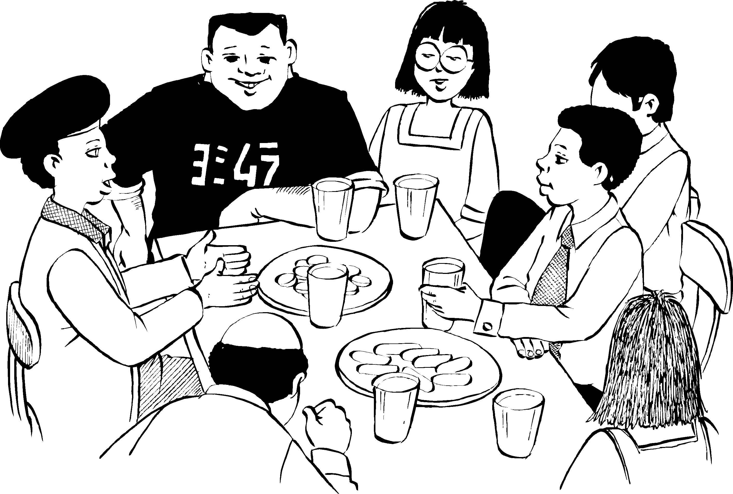
South African Institute for Distance Education (SAIDE)

Copyright
© South African Institute for Distance Education (SAIDE), 2008



The work is licensed under the Creative Commons Attribution-Non-commercial-Share Alike 2.5 South Africa License. To view a copy of this license, visit
http://creativecommons.org/licenses/by-nc-sa/2.5/za
South African Institute for Distance Education (SAIDE)
Box 31822
Braamfontein
2017
South Africa
Fax: +27 11 4032814
E-mail: info@saide.org.za
Website: www.saide.org.za

Acknowledgements
The South African Institute for Distance Education (SAIDE) wishes to thank those below:
For adapting and revising the module
- Ingrid Sapire – writer
- Tony Mays – writer
- Commonwealth of Learning (COL) – for the OER instructional design template
- Andre Plant – for the illustrations
- Tessa Welch – project manager
For participation in preparing and piloting the module
- Judith Inglis (University of the Witwatersrand)
- Sam Kaheru / Nicholas Muthambi (University of Venda)
- Sharon Mc Auliffe (Cape Peninsula University of Technology)
- Ronel Paulsen / Barbara Posthuma (University of South Africa)
- Tom Penlington (RUMEP at Rhodes University)
- Thelma Rosenberg / Sally Hobden (University of KwaZulu-Natal)
- Ingrid Sapire (RADMASTE, University of the Witwatersrand)
- Marinda van Zyl / Lonnie King (Nelson Mandela Metropolitan University)
For permission to adapt the following study guide for the module
UNISA (2006). Learning and teaching of Intermediate and Senior Mathematics (ACE ME1-C). Pretoria: UNISA
For permission to use in Unit Six
- UNISA (2006). Study Unit 6: Learning and Teaching of Intermediate and Senior Phase Mathematics.
- University of the Witwatersrand (2006). Module 3 of the Advanced Certificate for Learner with Special Education Needs: Understanding Cognitive, Emotional and Motivational Differences in Development.
- Department of Education (2005). Guidelines for Inclusive Learning Programmes. http://curriculum.wcape.school.za/resource_files/20091831_Guidelines_for_Curriculum_June_2005.doc.

Contents

How the unit fits into the module 1
Overview of content of module 1
How this unit is structured 3
Unit Six: Teaching All Children Mathematics 5
Welcome 5
Unit outcomes 6
A question of access and equity 7
The inclusive education policy for South African schools 9
The theory behind the policy 11
The medical model theory 11
The environmental theory 12
The maturational (developmental) lag theory 12
The ecosystemic theory 13
What the inclusive education policy expects of classroom teachers 14
Understanding and responding to barriers to learning and development 15
The importance of high expectations 21
Attitudes to difference 21
Understanding intrapersonal characteristics and their impact on school performance and learner development 24
Supporting diverse learners to do mathematics activities 26
Adapting a space and shape activity for different learning styles 28
Adapting a space and shape activity for learners with different ‘barriers’ to learning 28
Adapting number activities for diverse learners 31
Learners who are ‘gifted’ are also different 36
Planning for diversity in work on a learning outcome as a whole 39
Unit summary 42
Self assessment 43
References 44

How the unit fits into the module

Overview of content of module
The module Teaching and Learning Mathematics in Diverse Classrooms is intended as a guide to teaching mathematics for in-service teachers in primary schools. It is informed by the inclusive education policy (Education White Paper 6 Special Needs Education, 2001) and supports teachers in dealing with the diversity of learners in South African classrooms.
In order to teach mathematics in South Africa today, teachers need an awareness of where we (the teachers and the learners) have come from as well as where we are going. Key questions are:
Where will the journey of mathematics education take our learners? How can we help them?
To help learners, we need to be able to answer a few key questions:
- What is mathematics? What is mathematics learning and teaching in South Africa about today?
- How does mathematical learning take place?
- How can we teach mathematics effectively, particularly in diverse classrooms?
- What is ‘basic’ in mathematics? What is the fundamental mathematical knowledge that all learners need, irrespective of the level of mathematics learning they will ultimately achieve?
- How do we assess mathematics learning most effectively?
These questions are important for all learning and teaching, but particularly for learning and teaching mathematics in diverse classrooms. In terms of the policy on inclusive education, all learners – whatever their barriers to learning or their particular circumstances in life – must learn mathematics.
The units in this module were adapted from a module entitled Learning and Teaching of Intermediate and Senior Mathematics, produced in 2006 as one of the study guide for UNISA’s Advanced Certificate in Education programme.
The module is divided into six units, each of which addresses the above questions, from a different perspective. Although the units can be studied separately, they should be read together to provide comprehensive guidance in answering the above questions.
Unit 1: Exploring what it means to ‘do’ mathematics
This unit gives a historical background to mathematics education in South Africa, to outcomes-based education and to the national curriculum statement for mathematics. The traditional approach to teaching mathematics is then contrasted with an approach to teaching mathematics that focuses on ‘doing’ mathematics, and mathematics as a science of pattern and order, in which learners actively explore mathematical ideas in a conducive classroom environment.
Unit 2: Developing understanding in mathematics
In this unit, the theoretical basis for teaching mathematics – constructivism – is explored. Varieties of teaching strategies based on constructivist understandings of how learning best takes place are described.
Unit 3: Teaching through problem solving
In this unit, the shift from the rule-based, teaching-by-telling approach to a problem-solving approach to mathematics teaching is explained and illustrated with numerous mathematics examples.
Unit 4: Planning in the problem-based classroom
In addition to outlining a step-by-step approach for a problem-based lesson, this unit looks at the role of group work and co-operative learning in the mathematics class, as well as the role of practice in problem-based mathematics classes.
Unit 5: Building assessment into teaching and learning
This unit explores outcomes-based assessment of mathematics in terms of five main questions – Why assess? (the purposes of assessment); What to assess? (achievement of outcomes, but also understanding, reasoning and problem-solving ability); How to assess? (methods, tools and techniques); How to interpret the results of assessment? (the importance of criteria and rubrics for outcomes-based assessment) ; and How to report on assessment? (developing meaningful report cards).
Unit 6: Teaching all children mathematics
This unit explores the implications of the fundamental assumption in this module – that ALL children can learn mathematics, whatever their background or language or sex, and regardless of learning disabilities they may have. It gives practical guidance on how teachers can adapt their lessons according to the specific needs of their learners.
During the course of this module we engage with the ideas of three teachers - Bobo Diphoko, Jackson Segoe and Millicent Sekesi. Bobo, Jackson and Millicent are all teachers and close neighbours.
Bobo teaches Senior Phase and Grade 10-12 Mathematics in the former Model C High School in town;
Jackson is actually an Economics teacher but has been co-opted to teach Intermediate Phase Mathematics and Grade 10-12 Mathematical Literacy at the public Combined High School in the township;
Millicent is the principal of a small farm-based primary school just outside town. Together with two other teachers, she provides Foundation Phase learning to an average 200 learners a year.
Each unit in the module begins with a conversation between these three teachers that will help you to begin to reflect upon the issues that will be explored further in that unit. This should help you to build the framework on which to peg your new understandings about teaching and learning Mathematics in diverse classrooms.
.

How this unit is structured
The unit consists of the following:
- Welcome to the unit – from the three teachers who discuss their challenges and discoveries about mathematics teaching.
- Unit outcomes.
- Content of the unit, divided into sections.
- A unit summary.
- Self assessment.
- References (sources used in the unit).
There are two additional readings for Unit Six: Teaching All Children Mathematics. Both of them are referred to extensively, so it is a good idea to have them accessible while you are working through this unit.
- Extracts from: Department of Education (June 2005). Guidelines for Inclusive Learning Programmes, pp 6-18, pp. 59-66 [the full document can be downloaded from http://curriculum.wcape.school.za/resource_files/20091831_Guidelines_for_Curriculum_June_2005.doc ]
- University of the Witwatersrand (2006). ‘Understanding Intrapersonal Characteristics and their impact on School Performance and Learner Development’, Chapter 4 from Module 3 of the Advanced Certificate for Learner with Special Education Needs [adapted to serve as a reading for this unit].

Unit Six: Teaching All Children Mathematics

Welcome

“Over the past few weeks,” observed Millicent, “we’ve talked about how we can respond to the learning needs of different learners such as Thabo, Mpho, Faith and Mosioua. I have found these discussions very helpful in clarifying my own thoughts. How about you? If you did too, I was wondering whether we couldn’t make these discussions a more formal thing –and invite some of our colleagues to participate and share with us.”
“Well,” remarked Bobo, “I’ve also found the discussions useful but I’m not sure I can commit to regular formal meetings. It’s handy to bounce off ideas when the need arises though.”
“As you know,” said Jackson, “I like reading. I’ve been skimming through a recent new book on School Management by Alan Clarke. In the preface he talks about how useful he found it to share experiences with his peers in a semi-social gathering on a regular bass and how when his own position changed he left that group and other people came in. Maybe we could take it in turns to host discussions on particular issues and then invite people to attend the discussions that most interest them.”
“That seems like a good idea,” responded Millicent. “Maybe we could have a general discussion on the Inclusive Education policy and general challenges and solutions that people have found. Then perhaps we could take different Maths concepts and explore different ways of teaching and assessing those concepts to cater for the different needs of learners that teachers really experience.”
Think about the following:
- Do you think teachers can learn from others’ experiences in this way? Do you belong to any groups of this nature?
- If you were thinking about starting up a discussion group of this kind, what challenges do you think you would need to try and address to encourage colleagues to participate?
- What issues would you want to explore in such a discussion forum?
Comments
We like Jackson and Millicent’s ideas. We believe that teachers can often help one another to find solutions to the challenges they face in the classroom. Although we work with diverse learners in diverse learning environments, we can often adapt the solutions that other teachers have come up with to suit our own particular circumstances. This final unit will explore some of the general issues that we are likely to need to address in teaching and learning mathematics in diverse classrooms.

Unit outcomes

Upon completion of Unit Six you will be able to:
  Outcomes | - Understand what the inclusive education policy for South African schools means for ordinary classroom teachers  - Understand some aspects of the theoretical basis for the inclusive education policy  - Describe ways of analysing the diversity of your learners and understanding the impact of their individual backgrounds and personalities on their ability to learn mathematics  - Adapt existing mathematics tasks so that they cater appropriately for diverse learners  - Design a series of problem-based mathematics lessons that have multiple entry points and effective support strategies to enable diverse learners to develop mathematical reasoning and problem-solving ability

A question of access and equity
The approach to teaching and learning mathematics in this module is based on the fundamental belief that it is possible for all learners – without exception – to learn mathematics. As we have pointed out in the preceding units, for this to happen we need to
- get learners involved in ‘doing’ mathematics rather than relying on the traditional rule-based, teaching-by-telling approach
- understand how mathematical concepts are learned and give time in our lessons to develop mathematical reasoning skills rather than simply the mastery of routine procedures
- design and implement problem-based lessons that allow for multiple entry points to allow diverse learners to access the tasks at their own level of ability
- give learners multiple ways of representing what they have learned and give credit to these multiple representations, rather than assessing in a single way.
In this unit, we look at the specific requirements of the inclusion policy for South African schools. But the main purpose of the unit is to present ways of understanding the different kinds of learners we may have in our classes so that we can develop appropriate strategies to support them.
There are no easy answers or solutions to the challenge of helping all learners to learn mathematics. As a first attempt to help understand what this may mean, answer the following questions as honestly as possible.

  Activity 1 | Mathematics for all: some things to think about
 |  | Always | Mostly | Sometimes | Haven’t thought about this
 | - In your classroom, do you create an environment that encourages sensitivity and respect for self and others?
 | - Do you design your learning programmes specifically to include learners of different cultures and religions and affirm the richness and strength of cultural diversity?
 | - Do you consciously design your lessons so that all learners – girls as well as boys – get an equal opportunity to learn mathematics?
 | - Are you aware of the different socio-economic backgrounds of your learners and of how particular circumstances may affect learning?
 | - Do you go out of your way to contact parents and engage them in supporting you and their children to learn more effectively?
 | - Do you specially design your lessons to support learners whose home language is not the same as the language of learning and teaching?
 | - Are you aware of visual, auditory, oral, cognitive, physical, medical and psychological barriers to learning that your learners may have, as well as ways in which their learning may be supported?

Don’t be surprised if you didn’t feel so good after answering the above questions. What we want to show you in this unit is that even if you aren’t aware of all the details of the difficulties or differences of your learners, there are certain principles you can follow in your mathematics teaching that will enable to you to be responsive to diversity.
As question 1 in the Activity above makes clear, central to catering for diversity is the creation of an appropriate classroom environment in which
- all learners are encouraged to participate,
- no learner is allowed to limit another’s efforts to participate, and
- each child is expected to contribute to the problem-solving process.
Teaching and learning mathematics in diverse classrooms is a question of access – how to make it possible for different kinds of learners to access mathematical knowledge and skills.
It is also a question of equity – giving all learners an equal and fair chance of successful learning. In the United States, the National Council for the Teachers of Mathematics outlined critical aspects of what they called the ‘Equity Principle’ (Principles and Standards for School Mathematics, 2000: 12 - 14):
- Equity requires high expectations and worthwhile opportunities for all
- Equity requires accommodating differences to help everyone learn mathematics
- Equity requires resources and support for all classrooms and all students.
The South African policy that addresses teaching and learning for diverse classrooms, the inclusive education policy, is also directed by a concern for equity and access.

The inclusive education policy for South African schools
Before the inclusive education policy (contained in White Paper 6 on Special Needs Education) was drafted in 2001, understanding of special needs was limited to clearly identifiable medical conditions/disabilities: learners with visual, auditory, oral, cognitive, physical, medical, and psychological barriers to learning.
Learners with these medical conditions/disabilities were not supposed to be in ordinary schools, but in special schools. The new policy recognised, however, that there are many more ‘special needs’ or ‘barriers to learning and development’ than those in the list above, and not all barriers to learning have a medical definition. The focus in the new policy is therefore on barriers to learning in a broad sense, as well as on inclusion of learners with disabilities within the ordinary school system.
The policy changes are summarised neatly in the introductory pages of the Departmental document, Guidelines for Inclusive Learning Programmes:
In 1996 the government of South Africa amalgamated 17 Departments of Education, which had been designated along racial lines, to one Department of Education with one curriculum (Interim Syllabus) for all South African learners. Prior to 1996, learners experiencing barriers to learning and development were catered for in Special Schools, which were designated along categories of disability. Where learners who experienced barriers to learning did attend ordinary schools, it was largely by default, and very little was done by these schools to adapt teaching methods, the learning environment and assessment procedures to accommodate them. Learners were expected to adapt to the school. The majority of learners experiencing barriers to learning and development were unable to access education.
In July 2001 the Ministry of Education launched the Education White Paper 6 Special Needs Education: Building an Inclusive Education and Training System. White Paper 6 reminds us that our constitution challenges us to ensure that all learners pursue their learning potential to the fullest (EWP6 p.11). It commits the state to the achievement of equality and non-discrimination. The policy framework outlined in White Paper 6 outlines the ministry’s commitment to “the provision of educational opportunities, in particular for those learners who experience or have experienced barriers to learning and development or who have dropped out of learning because of the inability of the education and training system to accommodate the diversity of learning needs, and those learners who continue to be excluded from it”. (EWP6 p 11)
Education White Paper 6 on Inclusive Education sets out to address the needs of all learners in one undivided education system. It moves from the categorisation of learners according to disability (medical model) to assessing the needs and levels of support required by individual learners to facilitate their maximum participation in the education system as a whole. The focus is on ensuring that there is sufficient differentiation in curriculum delivery to accommodate learner needs and making the support systems available for learners and schools. It departs from the previous notion of referring learners with particular disabilities to specific special schools, but permits all schools to offer the same curriculum to learners while simultaneously ensuring variations in mode of delivery and assessment processes to accommodate all learners.

The theory behind the policy
You may be asking what the policy means when it says we need to move ‘from categorisation of learners according to disability (medical model) to assessing the needs and levels of support required by individual learners to facilitate their maximum participation’. A little theoretical background may help.
There are many theories of education which set out to explain how learners develop. Educational theory is the term used to describe the particular set of ideas and beliefs held by people who have observed children and their behaviour. Educational theorists then develop reasons for different behaviours or conditions they have observed in order that they might be understood. Theories are based on people’s experiences and opinions. Theories are beliefs that may have truths in them, but they are not “truth in themselves”. Because of this, most theories have useful aspects that we can use as tools for understanding children, as well as limitations. We will give a brief explanation of some of the theories that have been put forward to explain diversity in learner development.

The medical model theory
This theory explains learning difficulties in terms of neurological (brain) damage or dysfunction. According to the medical model, damage to the brain may be due to trauma to the brain (a head injury for example) or to genetic inheritance (meaning that damage is passed down from a parent to a child). The medical model theory views learning differences as intrinsic (inborn) to the learner, suggesting that the learner’s brain does not function adequately or "normally".
The medical model shows clearly that neurological impairments cause learning differences. However, it does not necessarily mean that, just because a child has a neurological problem, she is unable to learn. Rather, it means that a way around the problem must be found to help the child to learn.
Contributions made by the medical model
- The Medical Model created a change in perception towards learners with differences in that when parents and educators realised that the child was not simply being "lazy" but had a real problem, they were more likely to be sympathetic and helpful.
- It prompted research into the field of remediation causing educationalists to look for more effective teaching methods to meet these learners’ needs.
- It promoted further research into the field of learning and education.

Limitations of the medical model
- Can easily lead to labelling people in terms of their disability, which in turn encourages separation and distance from the mainstream.
- It fails to explain learning difficulties that occur in the absence of neurological damage.
- It places the ‘blame’ for the problem/s and difficulties the learner is experiencing directly on the learner. This can lead to negative attitudes being created in educators.

The environmental theory
The environmental model or theory differs from the medical model in that it explains learning differences in terms of inadequate or inappropriate environmental experiences. These experiences include poverty, inadequate schooling or difficulties within the family. Where the medical model focuses on nature (physical brain differences) as being the cause of learning differences, the environmental theory focuses on nurture (the up-bringing or care of children).
Environmental theory is rooted in what we call behaviourism. Behaviourism is a method of understanding and changing behaviour that relates to extrinsic (outside) factors. From an environmental theory perspective, learning differences in children and teenagers are seen to be extrinsic (external or outside of) to the learner. In other words, the problem causing the learning difficulty is a negative environmental influence rather than an internal or inborn cause.
Contributions made by the environmental theory
- The focus on the environment rather than inborn causes for behaviour.
- Research into the impact of the environment on learners and learning
- Brought about changes in parenting and teaching in an effort to create better learning conditions for learners.
Limitations of the Environmental Theory
- Only takes into account factors from the environment; factors within the person are not considered.
- Learner could be perceived as a “poor helpless victim” of circumstances and as a result, very little may be done to find ways of helping the learner overcome his or her circumstances in order to lead to a productive life.

The maturational (developmental) lag theory
Maturational lag theory is concerned with both cognitive development and social interaction. It is based largely on the child developmental theories of Piaget, Vygotsky, Erikson and Maslow. Maturational lag theory does not assume any illness or disorder within the learner. Rather it explains learning differences as a result of a learner maturing at a slower pace than other learners of the same age in terms of physical, cognitive or emotional development.
Contributions made by the maturational (developmental) lag theory
- Maturational lag theory has largely removed the issue of labelling. According to this theory, children are not described as having a problem, but are simply described as being at a different stage of development from their peers.
- Maturational lag theory has encouraged educators to be aware of developmental differences in the learners in their classrooms and to accommodate learners who are slower than their peers.
- It moves a step towards being more holistic in that parent and educator influences are also considered to be important in the child’s learning.
Limitations of the maturational (developmental) lag theory
- It is thought to be limited as it generally focuses on factors that are inborn to the child to the exclusion of other factors that may be resulting in learning differences.
- It can be misleading especially from a physical point of view as some learners who develop slowly physically do not necessarily experience learning difficulties.

The ecosystemic theory
The ecosystemic theory has tried to take into account all the positive aspects of the different theories you have already studied and combined them to create a theory that encompasses a variety of possible reasons for learning differences. The ecosystemic theory is a holistic method of looking at a learner from many different angles and perspectives.
This theory takes into account the way the learner interacts with his or her environment as well as the factors in the environment that may be affecting the learner. Environmental factors could be social, involving caregivers, educators and peers. They could be political. They could be economic. The ecosystemic theory also looks at the learner as an individual. For example, it looks at the learner in terms of personality, emotions, motivation and cognition and tries to identify ways in which individual characteristics may impact on learning.

Activity 2 | Theories for thinking about special educational needs  - Which of the theories above corresponds with the way in which you have thought about learners with special educational needs up to now? Explain your answer.  - Which theory do you think best represents and explains learners with special educational needs? Explain your answer.  - Find more information on one of the theories above from your education course (or any other material). See if you can find a learner with special educational needs and use this theory to explain:  - the way he/she experiences learning mathematics in your classroom  - the way in which you have traditionally related to this learner  - any ideas that you have about improving the way in which you teach this learner.

What the inclusive education policy expects of classroom teachers
A useful document to consult for an explanation of what the inclusive education policy expects of classroom teachers is a document, Guidelines for Inclusive Learning Programmes (Department of Education, 2005). The full text can be found at the following link, http://curriculum.wcape.school.za/resource_files/20091831_Guidelines_for_Curriculum_June_2005.doc. Key extracts have been selected for you in a reading that accompanies this unit.
It is useful to be aware of the basis for the very broad understanding of barriers to learning and development, but at the same time it is rather daunting. How much is an ordinary classroom teacher supposed to understand and to do? What are the implications of the inclusion policy for the teaching of mathematics?
The Guidelines for Inclusive Learning Programmes contains a very important statement:
It [the policy] moves from the categorisation of learners according to disability (medical model) to assessing the needs and levels of support required by individual learners to facilitate their maximum participation in the education system as a whole. The focus is on ensuring that there is sufficient differentiation in curriculum delivery to accommodate learner needs and making the support systems available for learners and schools.
It seems from this that three things are necessary:
- assessment of learner needs
- differentiation in curriculum delivery
- provision of support systems.
To assess learner needs, we need to be aware of what can create barriers to learning and development.
The Guidelines document also provides a useful summary of the more frequent causes of barriers:
- Disability as a barrier
- Language and communication
- Lack of parental recognition and involvement
- Socio-economic barriers
- Attitudes
- Inadequate opportunity for programme-to-work linkages
(White Paper 6, p.21 and 32 par. 2.2.6.3)
Some of these (for example, the last one) are of less importance for mathematics teachers, but it’s a good idea to familiarise yourselves with the range of barriers that have already been identified. For this, the extracts from the Guidelines document will help you.

Understanding and responding to barriers to learning and development
The Guidelines for Inclusive Learning Programmes gives pointers to how to deal in broad terms with each of the barriers. Some of the pointers/guidelines/policy implications may not be relevant to you as an ordinary teacher of mathematics. But you need to spend some time thinking about the implications of these guidelines for you. Some of your thoughts may well be questions.

Activity 3 | Understanding and responding to barriers to learning and development  Read the extracts from the Guidelines for Inclusive Learning Programmes document below.  Indicate next to each how the guidelines apply specifically to you as an ordinary classroom teacher involved with teaching mathematics.  The first one has been done for you.
 | - Disability as a barrier to learning and development
Most understandings of disability relate to individual deficit. Therefore, disability has always been regarded as a barrier to learning. These barriers include:
- Visual barriers
- Auditory barriers
- Oral barriers
- Cognitive barriers
- Physical barriers
- Medical barriers
- Psychological barriers.
 | Policy implications and guidelines for addressing disability as a barrier | Relevance for me as classroom teacher?
 | Learners who experience barriers to learning as a result of disability should be welcomed in ordinary school environments provided that the necessary support is in place for learners to achieve their full potential. | My attitude is important.
 | Teams that include parents, teachers and other relevant professionals should establish the nature and extent of support needed by the learner. | I will have to work in a team with other teachers to help.
 | Below are a few examples of how the system could be modified or changed to meet different kinds of support that individual learners may require:  - Modified access to buildings e.g. ramps, adapted toilets and speaker systems where applicable.  - Brailed signage on doorframes, passages and outbuildings.  - Enlarged print.  - Appropriate assistive devices e.g. Braillers, hearing aids, tape recorders, splints, adapted computers, wheelchairs, walkers, modified tricycles and standing frames.  - Therapeutic intervention.  - Learner-based and learner-paced teaching. | These are mainly school responsibilities, but it’s my job to take care of ‘learner-based and learner-paced teaching’.

Dealing with inclusion is clearly a whole school/whole system responsibility. The classroom teacher needs to work in a team, but there are also certain clear individual responsibilities – ‘learner-based and learner-paced teaching’ for learners with disabilities that are in the mainstream. What might this mean? At one level, it could simply be that if you have a physically disabled learner in your class, you don’t design activities that require the kinds of physical movements that will exclude her/him. But, of course it could be more complicated than that. Later in this unit, we will be looking at a case study of a learner with cognitive processing difficulties, and the kinds of strategies that can be used to help her.
Now repeat this Activity with another category of barriers from the Guidelines document.
Language and communication as a barrier
There are normally three main barriers related to language.
Firstly, learners are often forced to communicate and learn in a language which they do not usually use at home and are not competent to learn effectively.
Secondly, learners who use South African Sign Language as a language for teaching and learning and as a (language) subject did not have access to the language.
Thirdly, learners experience difficulties with communication. Learners who are non-speaking due to the severity of their disability experience enormous barriers to learning and development. These barriers arise from the general unavailability of augmentative and alternative communication (AAC) strategies to enable them to engage in the learning process, and more often than not find themselves totally excluded from learning and development experiences. AAC systems could consist of alternative communications systems, supplements to vocal communication and communication through facilitators.
Policy implications and guidelines to address language and communication barrier | Relevance for me as a classroom teacher?
- All learners are to learn their home language and at least one additional official language which includes South African Sign Language. Braille as a code can be used as a medium of teaching and learning.
- When learners enter a school where the language of learning and teaching is not their home language, the teachers of all the learning areas/programmes and the school should provide support and supplementary learning in the language of learning and teaching until such time that learners are able to learn effectively through the medium of that particular language. It is the responsibility of each individual teacher to ensure that the language of learning and teaching does not become a barrier to learning in such instances. Ideally, parents should be encouraged to participate in interventions regarding language.
- Learners should receive extra support in the language (‘subject’) which is also the language of learning and teaching. The learner should work towards and be assessed against the assessment standards of the appropriate language level (Home Language, First Additional Language or Second Additional Language).

You may have had some questions as you read this.
Surely the policy doesn’t mean that ordinary mathematics teachers have to learn sign language and Braille? Surely the issue of language is for the language teacher to deal with – not the mathematics teacher? We suggest that you return to these questions once you have worked through the unit.
Think about the policy and its implications some more with another cluster of barriers.

Barriers created by poor socioeconomic status
- Poor reading and print background (learners have not had pre-school exposure to literacy and print in general). Parents of such learners have often had limited education opportunities.
- Lack of exposure to numerical concepts.
- Sensory deprivation, resulting from a lack of opportunities during early childhood to explore the environment and wider world.
- Poor oral language development as a result of a lack of communication, interaction and learning opportunities.
- Poor self-image.
- Latch key children often experience social isolation and developmental deprivation.
- Impact of alcoholism and violence.
- Dysfunctional and anti-social behaviour patterns e.g. minor stealing and lying.
- Depression and hopelessness in both adults and learners.
- Substance abuse by learners, most commonly dagga and thinners.
- Teenage pregnancy.
- Learner-headed households and poor homes require additional responsibilities from learners.
- Mobility of families creates lack of continuity in learning as a result of school-hopping.
- Learners move from nuclear family to extended family.
- Late enrolment at school.
- Learners with offending behaviour including theft, housebreaking, assault and sexual misconduct
How do we overcome the socio-economic barriers? | Relevance for me as classroom teacher?
This is not a welfarist approach to poverty but rather a serious concern about the pedagogical implications of poverty.
- Teachers need to be sympathetic towards learners by creating a welcoming and supporting environment.
- Experiences that involve stimulation, enrichment and play must be created to compensate for the previous deprivation regarding reading, mathematics, spatial development and sensory experiences. These could often be enrichment programmes that involve first hand experiences (actual experience), play with concrete objects and reading to learners so they understand that print is meaningful.
- At a social level, an environment should be created that is comforting, that listens to the voice of learners, that is able to detect distress and depression. Appropriate referral to professionals should be made for formal assessment of depression.
- The school needs to reach out to poor communities, and should be a secure haven for learners.
- School nutrition programmes should act as incentives for poor and hungry learners to attend school.
- Schools should establish meaningful relationships with the courts, police, relevant NGO’s [e.g. child welfare and SANCA] and the Department of Social Services. Joint procedures to discourage any form of abuse should be developed. When learners become the perpetrators of abuse and crime the above contacts are essential.
- Where district-based support teams have been established they should be called upon to assist in matters of abuse and other learner-related issues. Where such support teams do not exist, institution-level support teams must be established.
- Use of accelerated academic bridging programmes and programmes-to-work linkages are vital for learners who enter the system late or who have experienced severe interruption in their schooling as a result of socio-economic factors.
- Baseline assessment should be used to establish current academic level and facilitate placement in the appropriate grade and/or set of learning programmes.
- Fast tracking to acquire basic literacy, numeracy and life skills through accelerated programs with a view to assisting the learner to catch up with his /her age cohort.

The main point that we were able to get from this list of relevance to mathematics teaching specifically is the acknowledgement that children who come from poor socio-economic backgrounds are likely to have missed out on basic concepts, so a lot will need to be done to help them ‘catch up’.

The importance of high expectations
What the Guidelines for Inclusive Learning Programmes do not address directly is the importance of having high expectations of all learners, and particularly those who are socio-economically disadvantaged. One of the major problems in mathematics teaching in this country has been the fact that in the apartheid era, learning mathematics was regarded as beyond the capability of the majority of the population – the socio-economically disadvantaged, then largely black population. So it is particularly important in this country to change not only our own perceptions of learners’ capabilities, but also their own.
The teacher’s belief in the ability of the learners to learn has a profound impact on the achievement of the learners. But often it is not enough. Teachers must work consciously with learners so that they develop a strong sense of self-esteem, and believe that they can achieve. If you expect learners to achieve, you will
- insist on accuracy and thoroughness – not accepting arguments that they can’t get it right.
- use mixed ability groups – so that more able learners challenge less able learners
- provide challenging material and a range of activities.
What disadvantaged learners need is not more ‘drill’, but more variety and challenge and excitement. Narrow, skills-focussed and highly prescriptive approaches do not work. Programmes that target disadvantaged learners by grouping them in special classrooms also do not work. What makes programmes succeed is a constructivist approach to teaching and learning and a positive belief in the learners.

Attitudes to difference
Although the Guidelines for Inclusive Learning Programmes do not specifically refer to the importance of high expectations, the document highlights the critical role of the teacher’s attitude to difference in a broad sense: not only attitude to class/socio-economic difference, but also to difference in race, gender, culture, disability, religion, ability and sexual preference:
Negative and harmful attitudes towards difference in our society remain critical barriers to learning and development. Discriminatory attitudes resulting from prejudice against people on the basis of race, class, gender, culture, disability, religion, ability, sexual preference and other characteristics manifest themselves as barriers to learning when such attitudes are directed towards learners in the education system.
As we have pointed out above, attitude is critical, but attitudes also need to be expressed in certain actions/strategies/approaches in the classroom teaching of mathematics.
One of the ways in which mathematics curriculum design has attempted to use difference positively is through the inclusion of what is known as ‘ethno-mathematics’. South African classrooms are now filled with learners from a wide variety of cultures. Culture relates to peoples’ beliefs, morals, customs, traditions, practices, and so on. Culture, therefore, influences their mathematical activity (e.g. number systems, measuring techniques, units used and so on), as it would any other activity. The study of different ways in which people invent terminology and ways of doing mathematics that are different from other people is called ethnomathematics. There is not sufficient time to go into this in detail in this unit on teaching and learning, as it is mainly an issue of the content of the curriculum. But teachers should recognise that:
- Every learner who enters the classroom represents a history and a culture and this is a very powerful tool for enabling all learners to connect to mathematics.
- Mathematics is the by-product of human ideas, creativity, problem-solving recreation, beliefs, values and survival. Contributions come from diverse people from all over the world.
Finally, the Guidelines for Inclusive Learning Programmes also talks about barriers that are a result of lack of parental recognition and involvement.
- Parents whose children do not utilise oral communication experience communication barriers with their children.
- Difficulties around parental support of learners may arise due to a range of situations e.g. a parent who cannot read Braille would not be able to support a grade one learner with his or her Braille homework.
- Parents are not always adequately informed of their children’s problems or progress, and therefore are often deprived of the opportunity to participate in their children’s development.
- Parents who are unable to understand the emotional and/or behavioural problems of their children may aggravate their barriers
- Non-involvement and non-recognition of parents by the system creates a lack of respect for parents as informed role players in the assessment and future development of their children.
- A lack of communication and support around HIV/AIDS infected or affected families creates barriers for learners from such families.
- Some parents abdicate all responsibility for all their children.
In the end what does all of this mean? It is easy to become overwhelmed by how many things we need to understand and do to deal with barriers to learning and development.

Activity 4 | Advice for teachers on implementing inclusive education  Stop for a moment and look back at what you have read thus far in this unit.  Imagine that you have been asked to speak for 3 minutes in assembly to the other teachers in the school about what is expected of teachers in implementing the policy of inclusive education.  What would be the three or four main points you would raise?  Remember these points need to get to the heart of the policy, but at the same time shouldn’t overwhelm teachers and make them give up before they start.

When we had finished reading through and thinking about all of this, we thought that the following points were important:
- Work hard on understanding your learners - in an ecosystemic way.
- Work hard on your own attitudes as a teacher – attitudes to disability, attitudes to difference.
- Realise that to deal with all the inclusion issues, you need to work in a team – it is the effort of the school as a whole that is required.
But a certain amount of curriculum adaptation is also necessary – as the Guidelines document says,
The focus is on ensuring that there is sufficient differentiation in curriculum delivery to accommodate learner needs.
The rest of this unit will look at how you make adaptations to your mathematics lessons to cater for learners with particular barriers to learning and development.

Understanding intrapersonal characteristics
It is not possible to deal in depth with all the barriers to learning and development listed in the Guidelines for Inclusive Learning Programmes.
So we have decided to focus on working with you through a process for understanding your learners and adapting your mathematics learning programmes in relation to a defined group of learners – learners with different and challenging intrapersonal characteristics. These learners are described in the chapter set as the second reading for this unit (see the Reading for Unit Six entitled Understanding intrapersonal characteristics.
Activity 5 | Understanding and catering for learners with different intrapersonal characteristics  Please work through the Reading for Unit Six: Understanding intrapersonal characteristics. It is a chapter from a module on understanding cognitive, emotional and motivational differences in learners based on the ecosystemic theory.  It begins with a case study of a teacher who is in despair about five particularly difficult learners in her class. The chapter explains how she learned to understand these learners, and how this changed not only her attitude to them, but also her understanding of how to teach them.  - When you have finished reading the chapter, reflect on what you have learned about:  - Different kinds of temperament and their effect on learning.  - The impact of poverty on learning.  - Different ways of processing information and how teachers can recognise and support these.  - Different learning styles and the implications for the design of classroom activities.  - Difficulties some learners may have with cognitive processes, and how teachers can recognise these.  - Which of the questionnaires or suggestions given in the chapter for supporting learners do you think you could use in your classroom? Why do you think they are helpful?

There are many points that you could have responded to in this Reading.
- We thought that the temperament questionnaire was particularly useful. It is clearly very important to understand the temperaments of our learners so that we can predict difficulties they may have. We also need to reassure and contain them, as well as structure their work to help them succeed.
- Issues raised in the chapter about to home background were also interesting. So often we penalise learners from poor backgrounds for not having enough school knowledge – but we don’t take the time to find out what they do know and can contribute to the class.
- Knowing about different ways the brain functions in a learning situation helps to explain the differences between learners. Some learners are top down processors (see the big picture, but can’t explain how they arrived at an understanding or answer), and some are bottom up processors (work with concrete detail, and have difficulty getting an overview). We thought it was important for teachers to encourage both types of processing.
- Often as teachers we design our lessons according to the way that we ourselves learn best. But there are different learning styles, and we need to make space in teaching and assessment to cater for those who learn best from new and active learning experiences (activists), those who like watching and thinking before they get involved (reflectors), those who like theories and models and systems (theorists), and those who like relating learning to real life experiences (pragmatists).
- We really felt for the teacher when it came to the discussion of Patience, the learner who had difficulties with paying attention, with planning, as well as with processing information. But we could see that understanding her difficulties did help Ellie to change her attitude towards Patience. Ellie also recognised that, although she wouldn’t be able to solve all Patience’s problems, there were some practical strategies that could help her cope better with classroom learning.
In the next section we will look at some mathematics activities from the previous units, and ask you to consider how to adapt them for the five different learners in Ellie’s class.

Supporting diverse learners to do mathematics activities
In your classes there will be a wide range of learners with diverse backgrounds. Some of your learners may have obvious barriers to learning; others may have struck you as simply disruptive or lazy. When you worked through the activity on the Reading you were exposed to five particular learners who face different barriers to learning. In this section we are going to treat these learners as our own real examples of learners with barriers to learning for whom we will adapt various activities. This will give you hands-on experience in adapting mathematical activities to suit learners in a diverse class room.
The first activity that we thought about adapting to suit the needs of Thomas, Joseph, Libuseng, Joyce and Patience was Activity 7 from Unit Four. On the next page is a copy of the activity.
Activity 6  (see Activity 7 in Unit Four) | Adapting a space and shape activity  Discuss how Activity 7 from Unit Four (copied below in this box), can be altered and expanded to cater for different learners by giving multiple entry points to the activity. Write out the differentiated activity sheet in full.  More Nets  - This box without a lid can be unfolded to form a net as shown:  - Draw two different nets for the same box.  - Draw a net which could be used to make a box with a lid.  - How would you change the net to make a cubic box?  - Why is a problem-based approach a good way to reach all learners in a diverse ability classroom?  - Discuss with your fellow mathematics teachers what is meant by ‘tasks with multiple entry points’ and ‘differentiated tasks’.  - What sort of groupings should be used in a diverse classroom? Why?

We thought carefully about each of these learners, and wrote down some of their characteristics. Then we thought of ways to make the activity more suited to their ways of learning, and to their particular needs.
On the next few pages are the ideas we came up with. See if you agree with us.

Adapting a space and shape activity for different learning styles
The task on nets is abstract, and would advantage learners with ‘theorist’ learning styles.
- Learners who are ‘activists’ might misinterpret the nets, and would need to have hands-on activities before drawing a net, such as cutting up boxes first, or taking a box and rolling it over on a surface to trace the outline of its net.
- Learners who are ‘reflectors’ would like to look back at what has been achieved, so a bit of maths writing could be included. These learners could reflect on the activity and describe their findings.
- Pragmatists should be given an opportunity for real life adaptation. They might like to make a box that could be used to wrap a gift.

Adapting a space and shape activity for learners with different ‘barriers’ to learning
We wrote up the following descriptions of the five learners described in the Reading for this unit, and made suggestions for adapting the activity for each of them.
Thomas
Thomas has a motivational problem. This means that the teacher needs to mediate the learning process. Thomas needs to be clear about the task; he needs to know exactly what to do. Then he needs to be kept on track – not in a disciplinarian way, but motivationally. He also has probably missed a great deal of fundamental work because of frequent absenteeism.
Suggestions for adapting the activity for Thomas
- Because of his potential conceptual backlog, his teacher needs to fill in missing information and concepts. This applies to prior knowledge, as well as language. He may know certain concepts, but may not be able to express his knowledge of them.
- Thomas’s emotional state is something that the teacher would have to keep tabs on – he needs encouragement throughout the completion of the task.
- Thomas would need to be provided with the box – he would not be able to bring one from home.
- Thomas needs a practical manageable activity. He will not deal easily with an abstract task. Some suggestions for making the activity more practical are:
- Take real boxes – paint the faces of the boxes different colours, label them.
- Put numbers on the faces of the box.
- Colour the edges of the box with different colours.
- Cut the boxes up and then remake them.
- Trace the outline of the cut and flattened box.
- Look at similar faces.
Joseph
Joseph has a problem with task completion, is easily distracted, and can lack focus.
Suggestions for adapting the activity for Joseph
- He needs to be allowed to work with a buddy, someone who balances him, rather than one who is like him.
- Like Thomas, he would respond to a practical concrete activity – he would have to have the actual box, not just a picture of the box.
- It would also help if the activity were linked to real life – to give him a purpose.
- To keep him on track, the teacher would need to acknowledge when he completes each individual task. A check list that could be ticked off at stages of completion would help.
- He also needs clear instructions and logic. Instruction c) of the task might not be clear enough for him – is it an open cubic box or a closed cubic box? This confusion might stop him from going on with the task.
- To prevent confusion, instructions need to be given as single steps and kept brief. You couldn’t say to him ‘draw two different nets’; you would have to say ‘draw a different net for the same box’, and then ‘draw another different net for the same shape’. If he had a check list, he could tick off items as he completes them. This would motivate him to continue as well as keep him on task.
A lot of activities that were used to adapt the activity for Thomas would be suitable for Joseph as well.
Libuseng and Joyce
These are learners who need extension activity and a challenge. Their learning style favours independent work.

Suggestions for adapting the activity for Libuseng and Joyce
- They are also more likely to work individually, so group work shouldn’t be forced. If they are placed in groups, they should be split up so that they learn to accommodate different styles of learning, and don’t simply stick together.
- The task may have to be supplemented to keep them challenged. For example, extend the task after question c) in the following ways:
- Ask how many different solutions/changes they can think of that will provide different nets for the same shape.
- Give a flat net with different colours, and ask which faces are opposite/adjacent, etc.
- Use a dice and make questions relating to numbers.
- Do a cross section and ask them to investigate the cuts (can also work with clay to do this).
- On computer – ask learners to write personal information on the faces and then make up the shape.
- Give learners a small project to design and make boxes with particular specifications; also give them a gift and tell them to wrap it in a box.
Patience
She has planning difficulties, as well as difficulties with simultaneous and successive processing. She also finds it difficult to keep concentration on the task.
Suggestions for adapting the activity for Patience
- The level of the task and the length of the task will have to be reduced for her:
- She might simply have to respond to ‘Show and tell’? type questions set only for her.
- Give her a box to cut out/already cut out, and ask her to trace around the cut box to create a net.
- She will need to be given clear and simplified instructions, and hands on support in carrying these out:
- Allow her to work with other learners who are slow (in speed), so that she is not under that much pressure.
- Spend time asking her questions that will reveal what has been correctly/incorrectly understood. Based on answers, you can illustrate further examples, show more hands on examples and so on, to help her to clarify her understanding of the concepts. This type of mediation is vital to assist her with the activity.
Many of the more practical activities that would help Thomas/Joseph would also help Patience.
Dealing with all learners together
The task needs to be discussed with the whole class at the end. The teacher can talk about some learners reaching one conclusion and some reaching other conclusions although they are doing the same activity. Even if not everyone understands the whole point of the task, it should be discussed as a whole with everyone to give them an opportunity to make sense of it in their own way.
It may seem like a lot of work to do all this, but you may have noticed as you read through our ideas for adaptation above that many of the variations of the activities and the scaffolding for doing the activity are useful to help different categories of learners – though the purpose for which you may use these are different, the methods will be the same. So it is not as overwhelming as it can seem at first to plan for a range of diverse learners in one class.
The important thing is to take the time to get to know the different needs your learners have, and then plan ahead to structure the activities so that each learner can engage and experience some success.

Adapting number activities for diverse learners
Now think through how you would make adaptations to two more activities for the five learners discussed in the Reading.

Activity 7 | Adapting number activities for diverse learners  - In a similar manner to the way in which it was done above, give details of how you would adapt the following two activities for Thomas, Joseph, Libuseng/Joyce and Patience:  Legfoot ( Activity 18 from Unit One)  Number Concept (Activity 16 from Unit Two)  They are reprinted below for your reference.  - Discuss the difference between the problems presented by the two activities which you have just adapted.  - What aspects of the adaptation were the same?  - What aspects of the adaptation were the different?  - Did you find it easier to adapt either one of the lessons? If so, explain why.
Example A  (Activity 18 from Unit One) | Patterns [from Unit One]  Pascal’s Triangle and the Leg-Foot Pattern  Pascal’s Triangle is a fascinating display of numbers, in which many patterns are embedded. In Western writings the Pascal Triangle was named after Blaise Pascal, who was a famous French mathematician and philosopher. Chinese mathematicians knew about Pascal’s Triangle long before Pascal was born, so it is also called a Chinese Triangle. It was documented in Chinese writings 300 years before Pascal was born.  In the triangle below, some ‘leg-foot’ patterns have been shaded. Can you shade more of the patterns that make Leg-foot in this Pascal’s Triangle? First look at the two examples that have been done for you. Then shade some more leg-foot patterns in the triangle.  - Now look at the numbers in the patterns that you have shaded.  - Can you see a relationship between the numbers in the leg and the foot of the leg-foot patterns that you have shaded? Describe this relationship in words.  - Write a numeric rule for the relationship you have identified.  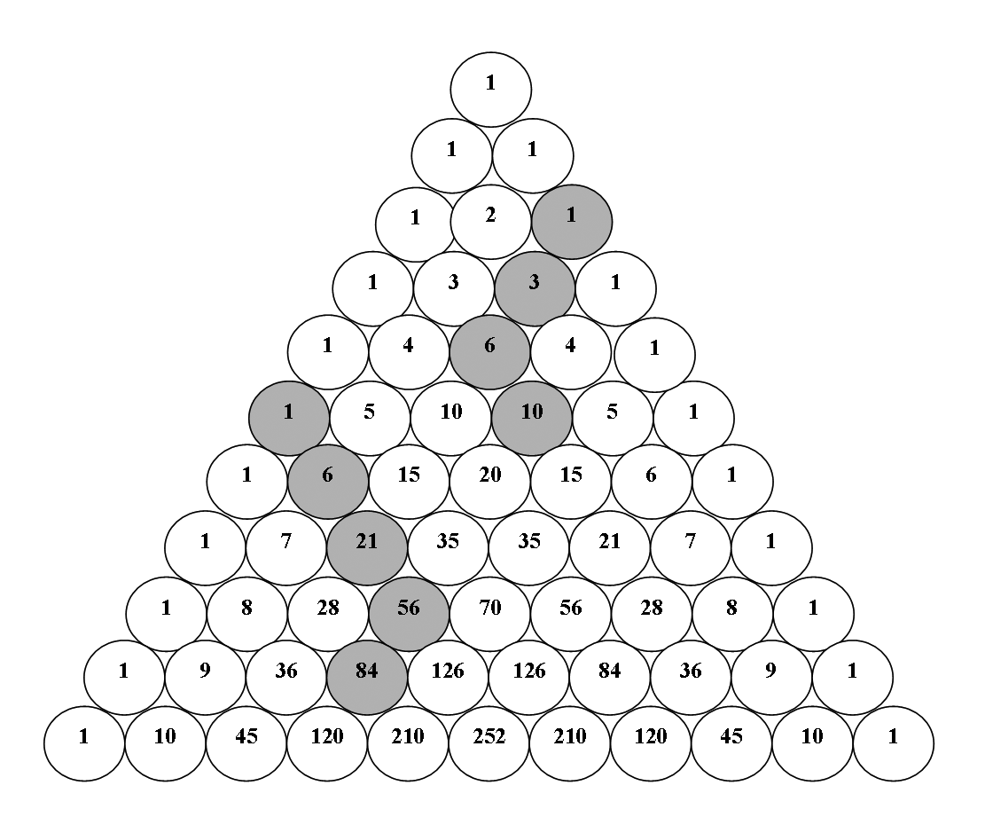
Example B (Activity 16 from Unit Two)
- In the number 10 212 the 2 on the left is _____________ times the 2 on the right.
- In the number 10 212 the 1 on the left is _____________ times the 1 on the right.
- In the number 80 777 the 7 on the far left is _____________ times the 7 immediately to the right of it.
- In the number 80 777 the 7 on the far left is _____________ times the 7 on the far right.
- In the number 566 the 6 on the right is _____________ times the 6 on the left.
- In the number 202 the 2 on the right is _____________ times the 2 on the left.
- In the number 1 011 the 1 on the far right is _____________ times the 1 on the far left.
- In the number 387, the face values of the digits are _____, ______ and _____; the place value of the digits (from left to right) are _________, ___________ and __________; and the total values represented by the digits (from left to right) are ____, ______ and _____.

Here are our ideas on adaptations to these activities for the five learners.
Example A (Leg foot pattern)
The wording of this problem is not clear enough for learners who may be struggling to access mathematical concepts. The ideas below deal mostly with this issue (of breaking down the instructions) and giving additional input where necessary.
- Clarify right/left in the creation of socks.
- Add lead in questions, particularly with regard to number sense, pattern recognition, Pascal’s triangle.
- Add many more steps into the instructions.
- Have different problem sheets for different learners – one for Libuseng/Joyce, and one for Thomas/Patience/Joseph.
- Ask about other patterns (after the leg foot pattern activity is completed) – extend this one.
- Give an empty triangle and call learners up to fill it in.
- Give some starting points for the socks (left and right).
- Organise the activity so that 50% can be done by everyone, followed by increasingly thought provoking questions. Teachers need to understand that some learners may not reach the final conclusion without some assistance (prodding and guiding).
- Call for generalisation of the sock pattern.
- Call for other patterns that the learners can identify.
Example B (Place value exercise)
A technical and precise activity like this one could present difficulties to some learners and will be difficult for learners who have not yet achieved the concept of place value. It should come at the end of series of lessons on place value as learners will need to have learnt all the required language to complete the task.
It is, however, a useful culminating activity as it will allow learners to express their understanding of the way in which numbers are written, by demonstrating their ability to distinguish between face, place and total value. This is fundamental conceptual number sense which is essential for all learners. When learners talk about the difference between face value and place value, they reveal their understanding of number concept. If they read the number 1 087 as 1-0-8-7 they are reading its face value, whereas if they read it as one thousand and eighty seven they show that they understand place value.
Because this activity will be difficult for some learners, it would be useful to have a number of additional lead-in questions/activities, such as the following:
- Start with smaller number examples (3 digit numbers), and then move to 4 or 5 digit numbers; or have the same types of numbers for movement from left to right and from right to left.
- Use the abacus with this activity. The abacus demonstrates place and face value effectively.
- Use Flard cards to decompose numbers, break down and build up numbers (expand to do both). Flard cards are particularly useful for learners struggling with this activity, since they can be used to show face value, place value and total value. (Flard cards are discussed in detail in Unit Two of this guide.)
- Write some of the questions using word names for numbers, and let learners tell a story about them.
- Link the activity to real life – use real numbers, cheques, bank balances, and so on.

Activity 8 | Now that you have thought about some adaptations using the guidance and feedback given above, for this activity you should produce a fully adapted version of the following activity.  You must write up your adaptation, with all the additional questions, instructions and information.  Refer to the activity in Example C below (see Activity 2 in Unit Three).

  Example C  ( see Activity 2 in Unit Three) | Understanding three-dimensional shapes  You will need old magazines and newspapers for this activity.  - Find pictures of three-dimensional objects in the magazines and newspapers.  - Cut these out and paste them onto paper.  - Give each object a name that describes its shape.  - Explain how you know what the object is.  - Try to find pictures of as many different objects as you can.  Here is an example: This is a picture of a rectangular prism.  It has 6 faces. Each face is a rectangle.    This is how you will be assessed:  - Can you identify the objects in the pictures?  - Do you find pictures that have a variety of different objects?  - Can you name the objects?  - Can you write down your reasons for naming the objects?  - Can you explain your reasons to the teacher?  - Is your work neatly presented?

Learners who are ‘gifted’ are also different
The Guidelines for Inclusive Learning Programmes document that you have been reading in this unit does not make reference to the ‘gifted’ or to ‘promising’ learners. But clearly such learners will also fit the description of ‘diverse’ or ‘different’. Often, learners who are more ‘gifted’ are ignored because teachers feel threatened by them, or because they are preoccupied with helping those who are struggling.
In the Reading about intrapersonal characteristics and their impact on learning, Libuseng and Joyce may well have fallen into the category of ‘gifted’ or ‘promising’. Ellie had difficulty with them because they came across as arrogant, and not willing to participate in class. But she found that if she gave them activities that challenged them, they responded well.
In this section, we will spend a little time looking at ways in which to cater for ‘gifted’, capable or ‘mathematically promising’ learners.
Firstly, teachers need to be able to recognise such learners. Van de Walle (2004: 99) points out that capable or promising learners generally have
good verbal skills,
curiosity,
imagination,
analytic thinking skills, and
the ability to concentrate and work independently.
Once we have been able to identify such learners, there is the question of how to handle them.
One strategy is to hand them on to someone else. That is, to put them up into the next grade. This is known as ‘acceleration’. But this strategy often is not helpful to such learners, as they may not have the emotional maturity to cope with being in a group of older learners
The second strategy is ‘enrichment’. This involves expanding the curriculum to include additional topics. It sometimes also means sending the ‘gifted’ to extra classes, to do activities that the other learners in the class do not do. But there is a problem with this strategy as well, as often these activities focus merely on fun, and don’t really extend or challenge.
Van de Walle’s view is as follows (2004: 99):
Both merits and cautions are associated with acceleration and enrichment. Capable and promising students should be challenged to move at an appropriate pace through the curriculum and should be exposed to as much quality mathematics as time permits. … Acceleration can have the effect of developing a large array of meaningless skills as students are pushed to learn more without exploring the ideas in a full conceptual manner. …Without adequate time, the guidance of a skilled teacher, and the benefit of directed discourse and exploration, students in acceleration programs tend to focus on mechanical skills. This will often be the case as well when students are left to study independently.
Too often enrichment programmes result in little more than “fun math time” with topics such as geometric puzzles, computer games, or the “problem of the day” Although good mathematics activities should be fun, they should accomplish much more. They should broaden students’ mathematical horizons, require students to think deeply, make connections to earlier ideas and to real contexts, and challenge them to ask questions, make conjectures, and reason about important ideas.
He argues that, although acceleration and enrichment may have their place, the really important thing is ‘the addition of depth’. He gives an interesting example of this (2004: 100):
In the regular classroom, teachers often “reward” highly capable students for finishing routine tasks quickly by having them do more exercises or more tedious exercises than those required of the rest of the class. For example, if the full class is working on the multiplication algorithm for multi-digit numbers, there is no redeeming value in having promising students who complete their work quickly do more exercises or exercises with more digits. However, they may be asked what would produce the largest or smallest products given four distinct digits to make two factors. Is there a general rule? Why does the rule work? What if there were five digits?
Even more interesting than the max/min task is that for some products, interchanging the digits in each two-digit factor produces the same result:
24 42
x 63 x 36
1512 1512
However, this is obviously not always the case, as a little experimentation will quickly show. When will this interchanging of the digits produce equal products and why? Students working on tasks such as these are engaged in a deeper exploration of the multiplication algorithm than simply understanding how it works and being able to use it.
There is no standard way of adding depth to mathematical investigations. But, according to Hashimoto and Becker (1999), the Japanese have an interesting approach. They say that to add depth, a mathematical problem must be made open in one of three ways (see Van de Walle 2004: 100):
the process is open (multiple paths to a solution are explored),
the end product is open (there are multiple correct answers to be discovered), or
the formulation of new problems is open (students explore new problems related to the one solved).
Example D | Here is an example of each form of open problem.  The diagram shows a box of chocolates with some removed.  How many chocolates are in the box?  How many chocolates remain in the box?  How many ways can you find to get the answer?  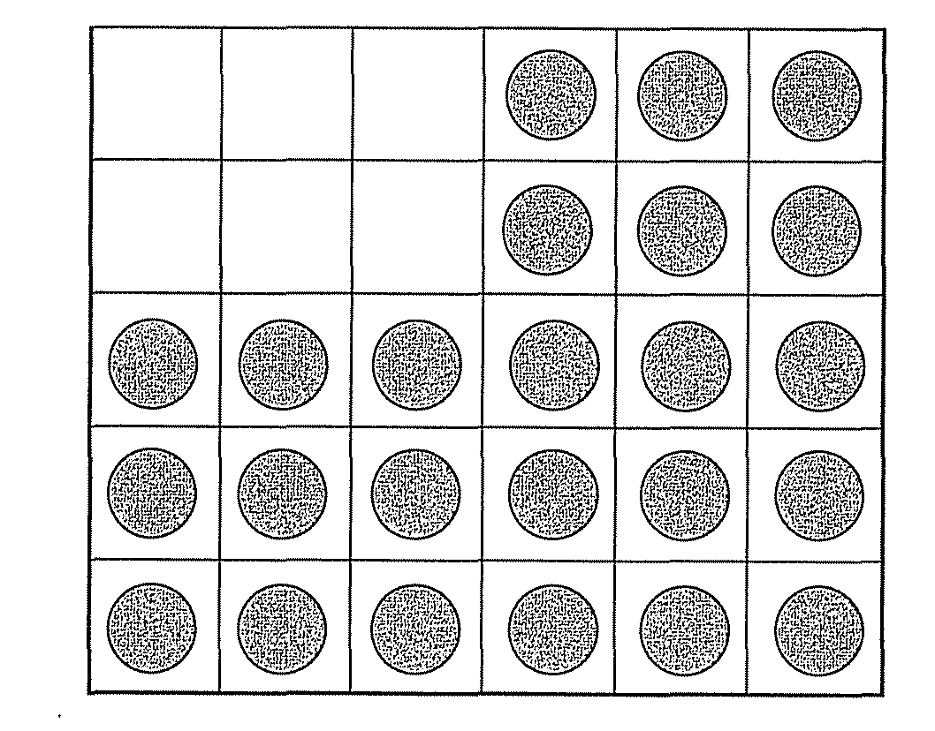  Of course, the chocolates can be counted one by one.  But another method is to note that there are three rows of six and two rows of three (3 x 6 + 2 x 3). Learners could be asked to explain three or four other ways to count the chocolates.  So, for learners like Libuseng and Joyce, teachers should avoid the temptation to give them ‘more of the same’ in order to keep them busy – it is the depth that ‘open’ problems create that is really helpful to capable or ‘gifted’ learners.

Planning for diversity in work on a learning outcome as a whole
In this part of the unit, we move from considering individual activities to looking at planning to cater for diversity in a whole section of work.
The Guidelines for Inclusive Learning Programmes provide support to teachers in thinking through the difficulties learners with barriers to learning and development may experience with the assessment standards for each of the learning areas. Extract 2 from the Guidelines in the Reading provides tables with notes for the mathematics learning area. You should take some time now to read through this extract carefully, as the comments and activity that follow are based on this Reading.
The notes that are given are extensive, yet if you think about them carefully, and compare the information they provide with the mathematics that you have to teach in your class, you will probably find that they do not cover every detail of adaptation required to properly address every aspect of the curriculum in relation to potential barriers to learning. It would be impossible to provide such detail. The aim of the tables in the Guidelines document is to guide you, and to help you develop your own skill of adapting your learning programmes to provide for all learners in your own particular diverse classroom.
When we read these tables, we noticed that there was no information given for the adaptation of Outcome 5, Data Handling. You will remember that when we did Unit Six on assessment, we spent quite a lot of time thinking through how to teach and assess data handling. So when we thought about how different learners would struggle with data handling, we came up with the following:
Implications | Strategies
Learner may have difficulties distinguishing between  - Table  - Tally  - Frequency table  - Histogram  - Bar graph/ double bar graph  - Line / broken line graph  - Pie chart  - Scatter plot | - Give different types of data to distinguish between discrete and continuous data  - Show the conventions of each one  - They must draw their own graphs from personally generated data  - Teacher needs to highlight the roll of bivariate data for example, shoe size and diameter of head  - Need to make sure that the learners have the necessary mathematical skills needed to draw a pie chart
May not have real life or concrete experience and are unable to sort physical objects according to one or more attribute(s) | Plan activities which are hands on using concrete aids, for example counters and box, sort sweets according to colour, collect stones, twigs and leaves and sort according to size/colour
May have difficulty understanding the difference between population and sample | - Ample exposure to different sampling activities e.g. select a few people from a class to represent the whole class  - Random sample e.g. choose any four people from a class  - Sports day – one person represents the team in a race, but the whole team supports.  - Relate it to real life situations. Show examples (Lotto)
Variables  - Dependent and independent variables  - Representation on the graph  - One-to-one correspondence | - Activities / data need to lead learners to realise that there is a difference between the category and the frequency  - The relationship between category and frequency needs to be understood
Pictograph representations  Appropriate keys | Give examples where learners select one icon to represent a group.
Questionnaires | Start with topic of interest. Analyse and lead into tallies and frequency table.
Scale | - Show convention using grid paper.  - Relate to shape and measurement.
Mean, Median, Mode | - Use real life situations.  - Practical examples must be given where mode is most important and so on.
Probability  - Terminology (certain/uncertain possibly/never, etc.)  - Numeric representation | Use real life situations, for example, Today is March 12. It will rain tomorrow. My sister is a boy.
We know that these ideas still need quite a lot of work, so we invite you in the next activity, to improve them.

Activity 9 | - In the table above, not all of the strategies are aligned to specific implications. Go through the whole table. Draw up a new table of your own, in which you align strategies with implications where appropriate.  - Many of the strategies that are given are not fleshed out fully. For example, the first one says ‘Give different types of data to distinguish between discrete and continuous data’. This does not give a practical example of the different types of data. It could be expanded to say (more meaningfully) ‘Give different types of data to distinguish between discrete and continuous data. Use collections of children, or items such as favourite food as discrete data items. Use the height or mass of the children as examples of continuous data.’  Expand on each of the strategies that are incomplete.  - Many of the “implications” given in the left-hand column have no given strategy for adaptation. Add to the table by providing strategies for each of these implications. Remember to give practical examples for each of your strategies.  - Compare the range of Assessment Standards covered in the Data Handling table above with the range of Assessment Standards covered in the table in the Guidelines for Inclusive Learning Programmes.  - What do you notice?  - Take some time to reflect on the table in the Guidelines for Inclusive Learning Programmes again, and think about things you would add to it.  This is not a task to be done in one sitting. This is a task that you could aim to complete over a year or years of teaching, and build up adaptations to the whole curriculum of each of the grades that you teach.  - The Guidelines for Inclusive Learning Programmes deal with a wide range of learners, but they do not deal with learners who may need enrichment. The ‘gifted’ learners in our classes also present a challenge. Teachers do need to prepare special activities for enrichment. Pick a grade that you are presently teaching and draw up table of enrichment activities that could be used when you are teaching. You should find some activities to address at least a few Assessment Standards from each of the learning outcome. (This is another task that you could aim to complete over a year or years of teaching, and build up enrichment activities for the whole curriculum of each of the grades that you teach.

Unit summary
Creating equity and access for all in mathematics teaching is a complex matter. If we are to move to a true equity model for all, we must make changes in curriculum, in teaching and learning, and in classroom culture. But even though it may seem overwhelming, there are four simple principles:
- Take time to understand your learners - in an ‘ecosystemic’ way;
- Work hard on your own attitudes as a teacher – attitudes to disability, attitudes to difference of all kinds;
- Realise that to cater fully for diversity, you need to work in a team – one teacher on her own cannot do all that is required;
- Make adaptations to your lessons for diversity of participation and diversity of opportunity. This is possible in mathematics teaching through following a problem-solving constructivist approach, where learners are meaningfully involved in doing mathematics at different levels.
The final outcome stated at the beginning of this unit is that you should be able to ‘design a series of problem-based mathematics lessons that have multiple entry points and effective support strategies to enable diverse learners to develop mathematical reasoning and problem-solving ability’. After working through the units in this module, you should be able to plan such a series of lessons. The activities on adapting lessons for different learners will have shown you that once you have thought through a few important ideas, many different learners can be accommodated by the same adaptation.
An ideal series of lessons would allow all learners to access mathematical concepts and skills. It would consist of carefully selected problem-solving tasks that would allow learners to learn and teachers to assess the learning process. The problem-solving tasks should:
- Present non-routine problems, rather than routine problems.
- Develop relational understanding supported by reflection.
- Focus on conceptual understanding, not just procedural knowledge
- Emphasise ability to reason, rather than merely to do computations.
- Take place in an environment that fosters enquiry and is non-judgemental.
- Have multiple entry points to allow for differentiation — allowing children to access tasks at their own level of ability.
- Have multiple ways for children to represent their knowledge in assessment tasks, as not all children learn in the same way.

Self assessment
Tick the boxes to assess whether you have achieved the outcomes for this unit. If you cannot tick the boxes, you should go back and work through the relevant part in unit again.
I am able to:
  Assessment
  # | Checklist | ☑
  1 | Understand what the inclusive education policy for South African schools means for ordinary classroom teachers | ❑
  2 | Understand some aspects of the theoretical basis for the inclusive education policy | ❑
  3 | Describe ways of analysing the diversity of your learners and understanding the impact of their individual backgrounds and personalities on their ability to learn mathematics | ❑
  4 | Adapt existing mathematics tasks so that they cater appropriately for diverse learners | ❑
  5 | Design a series of problem-based mathematics lessons that have multiple entry points and effective support strategies to enable diverse learners to develop mathematical reasoning and problem-solving ability | ❑

References
 | Clarke, A. 2007. The Handbook of School Management. Cape Town: Kate McCallum. (Distributed by MacMillan)  Croom, L (1997). Mathematics for all students - Access, excellence and equity. In NCTM, Multicultural and gender equity in the mathematics classroom - the gift of diversity 1997 Yearbook, NCTM (1).  Davidson, E & Kramer, L (1997). Integrated with integrity - culture, instruction and culture. In NCTM, Multicultural and gender equity in the mathematics classroom - the gift of diversity. 1997 Yearbook. NCTM (108-111).  Department of Education (2005). Guidelines for Inclusive Learning Programmes. http://curriculum.wcape.school.za/resource_files/20091831_Guidelines_for_Curriculum_June_2005.doc ].  Hilliard, AG (1995). Mathematics excellence for cultural minority students: What is the problem? In IM Carl (Ed), Seventy five years of progress: Prospects for school mathematics (109).  Masingila, JO & King, KJ (1997). Using ethnomathematics as a classroom tool. In NCTM, Multicultural and gender equity in the mathematics classroom - the gift of diversity, 1997 Yearbook. NCTM (119).  National Council for the Teaching of Mathematics (2000). Principles and Standards for School Mathematics. National Council of Teachers of Mathematics: Reston, VA.  Van de Walle, JA (2004). Elementary and middle school mathematics - teaching developmentally. Pearson: New York.  University of the Witwatersrand (2006). ‘Understanding Intrapersonal Characteristics and their impact on School Performance and Learner Development’, Chapter 4 from Module 3 of the Advanced Certificate for Learner with Special Education Needs.

