unit
Unit Four: Planning in the Problem-Based Classroom

From the module: Teaching and Learning Mathematics in Diverse Classrooms

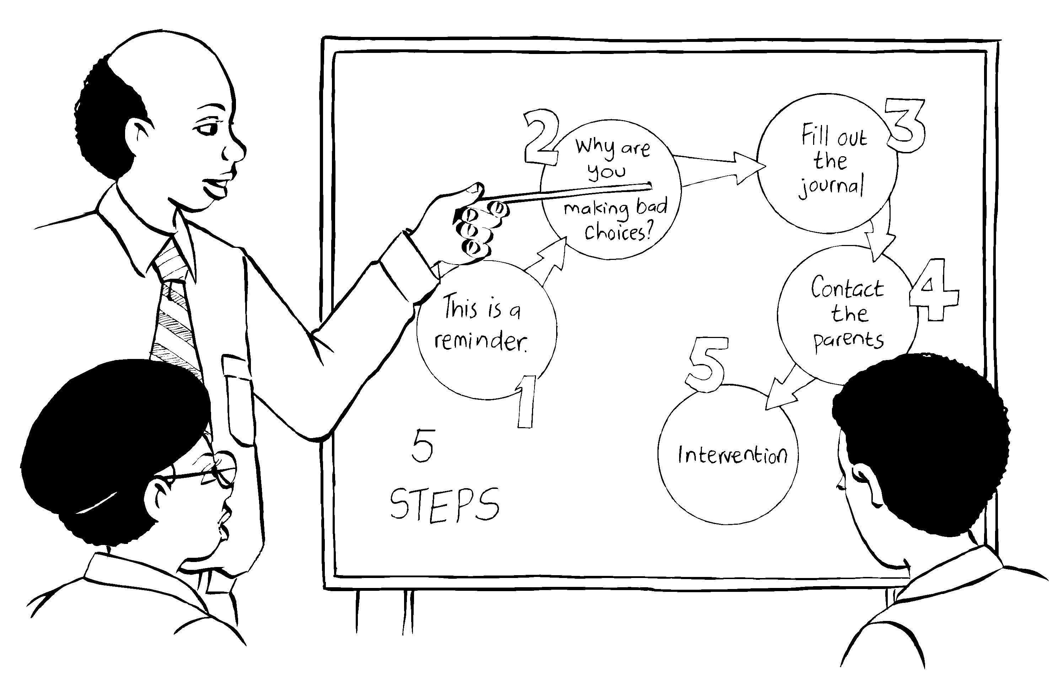

South African Institute for Distance Education (SAIDE)

Copyright
© South African Institute for Distance Education (SAIDE), 2008



The work is licensed under the Creative Commons Attribution-Non-commercial-Share Alike 2.5 South Africa License. To view a copy of this license, visit
http://creativecommons.org/licenses/by-nc-sa/2.5/za
South African Institute for Distance Education (SAIDE)
Box 31822
Braamfontein
2017
South Africa
Fax: +27 11 4032814
E-mail: info@saide.org.za
Website: www.saide.org.za

Acknowledgements
The South African Institute for Distance Education (SAIDE) wishes to thank those below:
For adapting and revising the module
- Ingrid Sapire – writer
- Tony Mays – writer
- Commonwealth of Learning (COL) – for the OER instructional design template
- Andre Plant – for the illustrations
- Tessa Welch – project manager
For participation in preparing and piloting the module
- Judith Inglis (University of the Witwatersrand)
- Sam Kaheru / Nicholas Muthambi (University of Venda)
- Sharon Mc Auliffe (Cape Peninsula University of Technology)
- Ronel Paulsen / Barbara Posthuma (University of South Africa)
- Tom Penlington (RUMEP at Rhodes University)
- Thelma Rosenberg / Sally Hobden (University of KwaZulu-Natal)
- Ingrid Sapire (RADMASTE, University of Witwatersrand)
- Marinda van Zyl / Lonnie King (Nelson Mandela Metropolitan University)
For permission to adapt the following study guide for the module
- UNISA (2006). Learning and teaching of Intermediate and Senior Mathematics (ACE ME1-C). Pretoria: UNISA
For permission to use in Unit Four
- UNISA (2006). Study Unit 5: Learning and Teaching of Intermediate and Senior Phase Mathematics.
- RADMASTE Centre, University of the Witwatersrand (2006). Mathematical Reasoning (EDUC 263) Chapter 6.
- Malati (1999). Geometry Module 3: Representations (nets, models and cross sections). Grades 4 to 7 Learner Materials.

Contents

How the unit fits into the module 1
Overview of content of module 1
How this unit is structured 3
Unit Four: Planning in the problem-based classroom 5
Welcome 5
Unit outcomes 7
Introduction 7
Planning a problem-based lesson 8
Variations of the three-part lesson 10
Work stations and games as problem-based activities 11
Teaching and learning in small groups 12
Why ‘group work’? 12
What is group work? 14
What makes co-operative learning work? 16
Reflecting on the work of the groups 19
Arranging learners into groups 20
Assessing group work 25
Self assessment in group participation 25
Peer assessment of group participation 26
Teacher assessment of group interaction 27
Dealing with diversity 29
Plan for multiple entry points 29
Listen carefully to learners 29
Drill and practice 31
What drill provides 31
What practice provides 32
Lesson planning 33
Unit summary 40
Self assessment 41
References 42

How the unit fits into the module

Overview of content of module
The module Teaching and Learning Mathematics in Diverse Classrooms is intended as a guide to teaching mathematics for in-service teachers in primary schools. It is informed by the inclusive education policy (Education White Paper 6 Special Needs Education, 2001) and supports teachers in dealing with the diversity of learners in South African classrooms.
In order to teach mathematics in South Africa today, teachers need an awareness of where we (the teachers and the learners) have come from as well as where we are going. Key questions are:
Where will the journey of mathematics education take our learners? How can we help them?
To help learners, we need to be able to answer a few key questions:
- What is mathematics? What is mathematics learning and teaching in South Africa about today?
- How does mathematical learning take place?
- How can we teach mathematics effectively, particularly in diverse classrooms?
- What is ‘basic’ in mathematics? What is the fundamental mathematical knowledge that all learners need, irrespective of the level of mathematics learning they will ultimately achieve?
- How do we assess mathematics learning most effectively?
These questions are important for all learning and teaching, but particularly for learning and teaching mathematics in diverse classrooms. In terms of the policy on inclusive education, all learners – whatever their barriers to learning or their particular circumstances in life – must learn mathematics.
The units in this module were adapted from a module entitled Learning and Teaching of Intermediate and Senior Mathematics, produced in 2006 as one of the study guide for UNISA’s Advanced Certificate in Education programme.
The module is divided into six units, each of which addresses the above questions, from a different perspective. Although the units can be studied separately, they should be read together to provide comprehensive guidance in answering the above questions.
Unit 1: Exploring what it means to ‘do’ mathematics
This unit gives a historical background to mathematics education in South Africa, to outcomes-based education and to the national curriculum statement for mathematics. The traditional approach to teaching mathematics is then contrasted with an approach to teaching mathematics that focuses on ‘doing’ mathematics, and mathematics as a science of pattern and order, in which learners actively explore mathematical ideas in a conducive classroom environment.
Unit 2: Developing understanding in mathematics
In this unit, the theoretical basis for teaching mathematics – constructivism – is explored. Varieties of teaching strategies based on constructivist understandings of how learning best takes place are described.
Unit 3: Teaching through problem solving
In this unit, the shift from the rule-based, teaching-by-telling approach to a problem-solving approach to mathematics teaching is explained and illustrated with numerous mathematics examples.
Unit 4: Planning in the problem-based classroom
In addition to outlining a step-by-step approach for a problem-based lesson, this unit looks at the role of group work and co-operative learning in the mathematics class, as well as the role of practice in problem-based mathematics classes.
Unit 5: Building assessment into teaching and learning
This unit explores outcomes-based assessment of mathematics in terms of five main questions – Why assess? (the purposes of assessment); What to assess? (achievement of outcomes, but also understanding, reasoning and problem-solving ability); How to assess? (methods, tools and techniques); How to interpret the results of assessment? (the importance of criteria and rubrics for outcomes-based assessment) ; and How to report on assessment? (developing meaningful report cards).
Unit 6: Teaching all children mathematics
This unit explores the implications of the fundamental assumption in this module – that ALL children can learn mathematics, whatever their background or language or sex, and regardless of learning disabilities they may have. It gives practical guidance on how teachers can adapt their lessons according to the specific needs of their learners.
During the course of this module we engage with the ideas of three teachers - Bobo Diphoko, Jackson Segoe and Millicent Sekesi. Bobo, Jackson and Millicent are all teachers and close neighbours.
Bobo teaches Senior Phase and Grade 10-12 Mathematics in the former Model C High School in town;
Jackson is actually an Economics teacher but has been co-opted to teach Intermediate Phase Mathematics and Grade 10-12 Mathematical Literacy at the public Combined High School in the township;
Millicent is the principal of a small farm-based primary school just outside town. Together with two other teachers, she provides Foundation Phase learning to an average 200 learners a year.
Each unit in the module begins with a conversation between these three teachers that will help you to begin to reflect upon the issues that will be explored further in that unit. This should help you to build the framework on which to peg your new understandings about teaching and learning Mathematics in diverse classrooms.
.

How this unit is structured
The unit consists of the following:
- Welcome to the unit – from the three teachers who discuss their challenges and discoveries about mathematics teaching.
- Unit outcomes.
- Content of the unit, divided into sections.
- A unit summary.
- Self assessment.
- References (sources used in the unit).

Unit Four: Planning in the problem-based classroom

Welcome
“You know,” said Bobo, “we’ve talked about diverse attitudes towards Maths, diverse ways in which learners solve maths problems and the fact that teachers teach Maths in diverse ways, but sometimes it’s not the Maths itself that is the issue. A few of my learners just get on and do the work whatever I give them. Some seem habitually naughty. And most of them seem to follow one of the two extremes. So sometimes I can get the whole class working productively and sometimes the whole class just seems to get out of control following the lead of the naughty ones.”
“I know what you mean,” remarked Millicent, “I try to focus on publicly rewarding good behaviour and dealing with discipline problems as soon as possible on a one-to-one basis. Otherwise the whole class starts to focus on your attempts to sort out discipline problems instead of the Maths. On a one-to-one basis it’s often possible to work out why learners are being “naughty” – sometimes they just crave the attention they don’t get at home; sometimes something has happened to them on their way to school; sometimes there are real learning difficulties that result in frustration rather any deliberate attempt to disrupt the class.”
“Yes,” replied Jackson, “that sounds like what Brigitte Thompson of Positive Behaviour Management also says. I read about her recently in the newspaper. She advocates tracking learners’ behaviour over time and notes that often the kids with discipline problems are intelligent, perceptive and have strong personalities. She argues that if we recognise and reward their good behaviour we can often help them become more positive leaders in the classroom.”
“That’s all very well,” remarked Bobo, “but sometimes the kids do get a bit out of control.”
“But that’s only because we let them,” said Jackson. “Thompson suggests that if all else fails, her five-step corrective plan should kick in. The first step is to issue a reminder when the first rule is breached. The second breach requires the teacher to ask the child why he or she is not making good choices. The third step involves getting them to fill out a journal, explaining their behaviour and exploring what they could have done instead. The fourth step is to contact the child’s parents and establish possible factors at home. The fifth breach requires the intervention of the head of department or the principal. I’ve tried it and it works quite well. I have needed to involve my HoD only once so far this year.”
“Yes,” added Millicent, “I’ve found that it is only a few learners who habitually seem to have problems that result in disruptive behaviour and I’ve also found that I have much fewer discipline problems when I can get them interested in what they are doing in class.”
Think about the following:
- Do you agree with Bobo that sometimes your Maths lessons get disrupted because of problems that are not actually related to the Maths? Can you think of any recent examples? How did you react to the disruptions?
- Are you able to identify learners in your own classroom who often present you with discipline problems? Do you have any idea why these children present these discipline problems? Does your lesson planning include strategies to try to pre-empt and minimise these problems?
- Millicent argues that in lessons in which she manages to capture the learners’ interest, she has fewer discipline problems in general. Is this also your experience? How can we make our maths lessons more interesting and stimulating for the learners?
Comments:
This module does not focus in detail on managing discipline. However, we believe that being able to anticipate potential discipline problems, recognising and rewarding constructive behaviour and dealing quickly and consistently with discipline problems that do emerge, are all ways in which we can help ourselves to manage our diverse classroom environments more effectively. We also believe that if we can plan lessons that will interest the learners and challenge them at an appropriate level, we will have fewer discipline problems generally and will be in a better position to deal one-on-one with any discipline problems that do arise.

Unit outcomes

Upon completion of Unit Four you will be able to:
  Outcomes | - Describe the step-by-step process of planning for a problem-based lesson.  - Write out a well thought out and concise lesson plan based on a problem-based strategy.  - Critically discuss some variations of the three-part lesson.  - Discuss how workstation activities or games can be profitably and meaningfully used to enhance a problem-based lesson.  - Discuss the effective use of group work  - Explain the differences between competitive learning, individualistic learning and collaborative learning  - Discuss the effective use of collaborative/co-operative learning  - Plan for reaching all learners through effective problem-solving strategies - to be used in an increasingly diverse classroom.

Introduction

One of the major hurdles facing teachers is translating the theoretical constructs into action in the classroom (Moodley, 1992). Your own understanding of the model and more importantly your confidence and conviction in using it is crucial to its implementation. This unit will focus on planning in the problem-based classroom – in an attempt to give you the confidence and competence to pursue this approach with your learners. You know that people involved in a teaching-learning situation would find it difficult to teach effectively without using a good lesson plan.

The three-part lesson format described in Unit Three provides a basic structure for problem-based lessons. That basic framework resulted from the need for learners to be engaged in problems followed by discussion and reflection.

We need to keep in mind that teachers, according to Lester (1994):
Play a key role in the development of their students’ conceptualisation of a mathematical self.
When planning the lesson, make provision for the teacher's role – which should be that of a guide or facilitator and not an authority. This means that the teacher chooses which problems and tasks to use, and guides the discussion of these problems, but the teacher does not pronounce solutions.
It is also an important strategy not to tell the learners everything they need to know as this will restrict the development of learner-initiated activity that is a natural consequence of learners’ curiosity - and will encourage them to take a passive role in their education (Lester, 1994).
Teaching is a practical activity. However, this challenging activity demands reflection and insight. As you work through this study unit, develop an inquiring mind and continually ask why certain activities are performed in a particular way. Think and do should be the key words. Krüger and Müller (1988) insist that this act of teaching demands that one should perform teaching activities skillfully.

Planning a problem-based lesson
It is very important that you give adequate thought to the planning of your lesson. Remember that every class is different, and choices of tasks and how they are presented must be made daily to best fit the needs of the learners and the defined outcomes. Van de Walle (2004) recommends the following steps for planning a problem-based lesson.
STEP 1: Begin with the mathematics!
- Articulate clearly the ideas you want learners to construct - something new or unfamiliar.
- Describe the mathematics, not the behaviour.
- For skills as intended outcomes – identify the underlying concepts and relationships.
STEP 2: Consider your students
- Consider what the learners already know or understand about the topic. Are there any background ideas that they need to still develop?
- Be sure that your objectives are not out of reach.
- For learning to take place, there must be some challenge - some new idea within the grasp of learners.
STEP 3: Decide on a task
- Keep it simple! Good tasks need not be elaborate.
- Build a task bank – from resource books, journals, workshops, in-service programmes and conferences.
STEP 4: Predict what will happen.
- Predict, don’t hope! Use the information about what learners know to predict all of the things your learners are likely to do with this task.
- If they flounder, provide hints or modifications in the tasks for different learners.
- Think about whether your learners will work alone, in pairs, or in groups.
- Revisit the task if you find it inappropriate at this stage – modify the task if necessary.
- These first four decisions define the heart of your lesson. The next four decisions define how you will carry out the plan out in your classroom.
STEP 5: Articulate learner responsibilities.
- For nearly every task, you want learners to be able to tell you:
- What they did to get the answer.
- Why they did it that way.
- Why they think the solution is correct.
- Plan how learners would supply this information. They could write individually or prepare a group presentation - in their journals, worksheet, chart-paper and so on. There is an option of no writing - learners could report or discuss their ideas.
STEP 6: Plan the 'before' portion of the lesson.
- Prepare the learners by working quickly through an easier related task or some related warm-up exercise.
- Articulate what is required of the learners in terms of their responsibilities.
- Present the task and 'let go'! They could brainstorm ideas or estimate ideas.
- Consider how the task can be presented – written on paper, taken from the text and so on.
STEP 7: Think about the 'during' portion of the lesson.
- What hints can you plan in advance for learners who may be stuck?
- Think of extended questions or challenges you can pose to learners who finish quickly.
- Tell learners in advance how much time they have to complete the task but be flexible.
STEP 8: Think about the 'after' portion of the lesson.
- How will you begin the discussion? List the options and then return to individual learners or groups to explain their solutions and justify their answers.
- For oral reports, think about how you would record on the board what is being said.
- Plan an adequate amount of time for your discussion.
STEP 9: Write your lesson plan.
The outline here is a possible format of the critical decisions:
- The mathematics or goals.
- The task and expectations.
- The ‘before’ activities.
- The ‘during’ hints and extensions for early finishers.
- The ‘after’-lesson discussion format.
- Assessment notes (whom you want to assess and how).

Variations of the three-part lesson
Not every lesson is developed around a task requiring a full period to complete. The basic concept of tasks and discussions can be adapted to form mini-lessons. The three-part format can be compressed to as little as 10 minutes. This will allow you to plan two or three cycles in a single lesson.
Consider the use of mini-lessons when the learners do not require the full period - where the basic concept of tasks and discussions can be adapted to problem-based lessons. Another strategy for short tasks is ‘think-pair-share’. Learners first work on their own, then pair with classmates and discuss each other’s ideas, before sharing their ideas and solutions with the whole class.

Work stations and games as problem-based activities
Getting learners to work at different tasks or games at various locations around the room can also be a useful teaching and learning strategy for a number of reasons:
- The use of workstations is a good way to manage materials without the need to distribute and collect them. This strategy can also be useful in large classes giving all learners the opportunity to interact with various materials. In this instance it is important that the teacher ensures that meaningful activities are taking place at each of the stations.
- Another advantage of using workstations is that they allow you to differentiate tasks when your learners are at different stages in the development of concepts.
- These work stations can be used for problem-solving activities or for the opportunity for learners to have several opportunities to practise a skill in different contexts.
It is important to note that for a given topic, you may prepare from four to eight different activities and so it is advisable to teach or explain about the activity to the full class ahead of time so that the learners get on with the task without wasting time.

  Activity 1 | Planning a problem-based lesson  - Reflect analytically on the nine steps given above for the planning of a problem-based lesson.  - Thereafter, describe in your own words the decisions that must be made for each of the nine steps.  - Choose a topic and plan a lesson for a grade of your choice, following the nine steps above.  - Reflect on where you considered it necessary to adapt the three-part lesson format and why you did so.  - Do workstation activities or games fit the definition of a problem-based task as discussed in Unit 3? Explain your response clearly.  - Explain how you would do the 'after' portion of a lesson (i.e. discussions) when learners are working at work stations.

Teaching and learning in small groups
A key strategy for problem-based lessons is organising for teaching and learning in small groups. The material in this section is from a module entitled Mathematical Reasoning from the RADMASTE Centre, University of the Witwatersrand.

Why ‘group work’?
The new curriculum emphasises the importance of group work as one of the ways in which teaching and learning activities can occur. We have already discussed the importance of the active participation of learners in the teaching and learning process, and the place of communication in this process. When learners are allowed to work together in small groups they can talk and discuss things amongst themselves. If learners in small groups are supplied with appropriate activities and tasks, they can use the opportunity to talk to each other to construct meaningful understandings of concepts. One of the Critical Outcomes in the new curriculum centres on team work and requires that each learner can:
Work effectively with others as a member of a team, group, organization or community.
Small group interactions enable learners to develop certain skills such as:
- strong interpersonal skills because they have to learn to communicate with their peers and to negotiate towards a goal;
- strong co-operative and collaborative skills - these skills can help balance the strong competitiveness that is current in today’s world;
- strong problem solving and critical thinking skills - these skills are developed through the shared knowledge and abilities focussed on the problem as well as from evaluation of each other's contributions.
While OBE is not all about group work, it does play a significant part in fostering new approaches to teaching and learning.
Activity 2 | - Tick the response that best fits how strongly you agree or disagree with the statements.
 |  |  |  | Strongly agree | Agree | Disagree | Strongly disagree
 | a | Everyone in a group can be involved in the learning.
 | b | It’s easy to do nothing in a group and to allow the others to do all the work.
 | c | OBE is all about learners working in groups.
 | d | Mathematics lessons need to be specially designed to allow for group work.
 | e | You can use group work for other subjects but not for mathematics.
 | f | If you seat learners in groups then they will copy the work of the others in the group.
 | g | Learners work best when they work on their own.
 | h | Learners work better in groups because they enjoy working with their friends.
 | i | Learners work less effectively if they are in groups.
 | j | Group work is not possible for learning mathematics.
 | k | If you seat learners in groups then they will be involved in co-operative learning.
 | l | The learners will pass on incorrect information to each other and confuse one another
 | m | Group work means a lot of extra teacher preparation and administration.
Activity | - Tick the response that best fits how you think group work might work/works in your classroom.
 | a |  | I have tried having the learners work in groups but the class is too big
 | b |  | I have never tried group work in my classroom as the learners are too noisy
 | c |  | The learners always work in pairs so I do not need to have small groups
 | d |  | The learners I teach do not like working in groups
 | e |  | The learners in my classes often work in groups
 | f |  | The desks in my classroom are arranged in lines so there is no opportunity for group work
 | g |  | The desks in my classroom are arranged so the learners can work in pairs
 | h |  | I teach in another teacher's classroom and I am not allowed to move the desks

What is group work?
The main idea behind group work is that learners can help each other in the learning process. But, we wish them to share more than just the answers. They help each other to understand concepts better and to build new knowledge. Learners who are not familiar with working in groups may feel uncomfortable initially but, with perseverance, they can develop sound co-operative behaviour.
Whilst working in groups, learners can get clarity about their ideas and practise their skills. This usually occurs by means of discussion to reinforce concepts and practical activities that allow the practice of skills already learnt. Usually special worksheets are designed by the teacher, to guide the learners’ discussions and activities.
Another form of group work is problem-based and requires learners to work in small groups in order to discover or ‘uncover’ new concepts and ideas. Through experimenting, thinking and talking, the learners interact with each other and with the problem, and construct new knowledge. The teacher’s role is to mediate the learning within the groups.
In any classroom a teacher may structure lessons so that learners:
- Compete in a win-lose struggle to see who is the best.
- Work independently on their own learning goals as individuals learning at their own pace and in their own space to achieve a pre-set criterion of excellence
- Work co-operatively in small groups, ensuring that all members master the assigned material.
Below are three different ways of learning, with the principle behind each type.
COMPETITIVE  LEARNING | The principle here is:  I swim, you sink; I sink, you swim.  If I achieve my goals you cannot achieve yours
- This learning fosters negative interdependence.
- Learners obtain assigned goals if and only if others fail.
- The teacher is perceived as the major source of support; as a referee and/or judge.
- If learners do not feel that they have an equal chance to win they often give up and do not try.
- A typical teacher response is:
‘Who has the most so far?’ or ‘what do you need to do to win next time?’
INDIVIDUALISTIC LEARNING | The principle here is:  We are each in this alone.  I do not depend on you to achieve my goal
- Learners work on their own; there is no interaction.
- Learners seek help only from the teacher; the teacher is seen as the major source of information.
- The learner celebrates only his own success.
- A typical teacher response is:
‘Do not bother Mike while he is working. Raise your hand if you need help.’
- Learners are encouraged to compete with themselves to strive for excellence.
- Learners are not held back by those learners who have no interest in learning anything.
CO-OPERATIVE LEARNING | The principle here is:  We sink or swim together.  I can only achieve my goal if you achieve your goal.
- There is positive interdependence.
- Learners are working together to achieve shared goals.
- There is prolonged interaction with much helping, sharing, general support and encouragement.
- Learners only reach goals if others also reach them.
- The teacher monitors and intervenes in learning groups.
- The teacher facilitates the learning of collaborative skills.
- A typical teacher response is:
‘Mike, can you explain your group’s answer to question 3?’ or
‘Ask for help only when you have consulted all group members’.
The goal of co-operative learning is the instructional use of small groups so that learners work together to maximise their own and each other’s learning.

Activity 3 | - Write a paragraph describing whether you encourage competitive, individualistic or co-operative learning in your classrooms.  - Based on what you have read above and your own experiences draw up a table of the advantages and disadvantages of having the learners in your classroom working in small groups.

What makes co-operative learning work?
There is more to co-operative learning than a seating arrangement! For co-operation to work well, teachers have to explicitly structure five essential elements for any lesson in which group work plays a part.
Positive interdependence
The members of the group must believe that they cannot succeed unless everyone succeeds.
Examples of strategies that encourage this are:
- the overall group score has to be above a certain amount
- each member of the group has to score at least a set level
- the group must produce one product.
Activities and tasks need to be carefully structured so that each member of the group has some resource or material that others need. They therefore cannot achieve the desired goal on their own. To help achieve this, members of the group are often assigned a specific role, e.g. reader, checker, scribe.
Individual and group accountability
The purpose of co-operative groups is to make each member of the group a stronger individual in his or her own right. The group members must understand that they cannot ‘hitch-hike’ on the work of others. They are required to work as a whole and they may need to help one another to achieve the desired goal.
It is important to provide a structure in which group members can hold each other accountable; this might take the form of peer assessment within the group.
For example:
REFLECTION ON GROUP PROGRESS
 |  | Agree |  |  | Disagree
My group | - had clear goals | A | B | C | D
 | - made good progress | A | B | C | D
 | - stayed on task | A | B | C | D
 | - helped each other | A | B | C | D

If groups are kept small, it is possible to observe and record the frequency of participation of the group members. An example of a teacher-observation sheet is shown below:
OBSERVATION FORM
NAME | Contributes information and ideas | Encourages participation; invites others to speak | Checks for understanding | Gives the group direction | Listens to others
The table below (taken from the Learning Programme Guidelines for Mathematics) shows a checklist for the teacher on group work skills. (Other criteria assessing group work skills may also be used.)
Criteria | Yes | No
Does the learner perform designated task in the group?
Does the learner participate fully in group activities?
Does the learner listen to other group members?
Is the learner focused on the group activities?
Does the learner assist other group members when there is a need?
The teacher should try to find time to listen to each group, to intervene when necessary, to encourage improvement of academic skills and small group skills.
Face-to-face interaction
It must be made clear that groups must meet to do the work. Some time must be scheduled into class time as you cannot assume that they are all able to meet for homework.
Interpersonal and small group skills
Interpersonal and small-group skills do not magically appear. If you are going to use co-operative learning successfully, you have to find ways to teach the learners how to behave towards each other, so that their groups are productive. All learners must be taught the skills for high quality collaboration; learning how to work together is a process and there is a need to develop certain ‘small-group skills or behaviours’. Learners do not always find these skills easy to identify or to put into practice. Skills and behaviours necessary for effective co-operative learning include the following:
- encouraging participation  - expressing warmth  - contributing ideas  - summarising  - checking for understanding  - relieving tension by joking  - keeping the peace | - expressing support  - listening  - giving direction  - staying on the task  - using quiet voices  - explaining answers  - criticising ideas without criticising people
The learners need to trust each other; communicate accurately, accept and support each other and resolve conflicts constructively.
Teachers play a vital role in ensuring that groups function effectively. The teacher must continually reinforce the behaviours that he/she wishes to see by encouraging the learners to persevere in practising the skills they have highlighted.

Reflecting on the work of the groups
While groups should be consistently monitored to assess academic progress and to assess the use of the small group skills, the teacher needs to reflect on each session to assess the quality of the interactions. It might be necessary to decide what actions/interactions within the groups worked well and which did not; which interactions were or were not helpful etc. This enables the teacher to set goals as to how to improve the effectiveness of the groups.
International research has found that group work enables:
- higher achievement and increased retention
- more frequent higher level reasoning, deeper understanding and critical thinking
- more ‘on task’ and less disruptive behaviour
- greater achievement motivation and intrinsic motivation to learn
- greater ability to view situations from the perspective of others
- more positive accepting and supportive behaviours with peers regardless of gender, ability, ethnic, social class or handicap differences
- greater social support
- more positive attitudes towards teachers, principals and other staff
- more positive attitudes towards subject areas, learning and school
- greater psychological health adjustment and well-being
- more positive self-esteem based on self-acceptance
- greater social competencies.
Activity 4 | In this activity you will get your class to work in pairs on a task and then reflect on how successful you think the task was with the class. Remember that it takes a little while for learners to get used to working together if they have never done it before.  - Divide the class into pairs.  - Give the learners a puzzle or mathematics problem to complete with their partners.  - Observe and take notes as they work. Interact with pairs if they need assistance.  - If possible give each learner a short self assessment on how they liked/felt about working with a partner.  - At the end of the lesson write a short reflection on how well the learners worked together.

Arranging learners into groups
There are many ways of organising learners into groups. There may be times when the teacher prefers to group learners with similar ability, at other times he/she might want to group learners with different levels of ability. Much of the research on co-operative learning seems to indicate that heterogeneous (mixed-ability) groups are best. Educationalists point out that a mix of ability, gender, language, culture and social background allows more diversity of thought, with more giving and receiving of explanations. However, when using mixed-ability grouping, it is not a good idea to put very weak learners with high-achievers, as the learners who struggle may be too shy to offer their suggestions. Some educationalists have indicated in their research that all learners tended to be active participants in groups with narrow ranges of ability.
To begin, it is best to start by working in pairs. After any whole class discussion, simply suggest that learners help each other complete their worksheets or exercises. When new concepts are introduced the pairs can be encouraged to explain these concepts to each other, and to check for understanding. This ensures that all students are actively involved.
After a time of working in pairs, learners could be assigned to groups of 3 or 4. When assigning learners to groups the teacher should try to ensure that each group has at least one learner who is confident and competent at mathematics. To encourage a co-operative and supportive group atmosphere it is best to keep learners in the same group for at least one marking cycle. Working together for an extended period of time allows a team spirit to grow and encourages a working relationship to develop. However, for various reasons, learners do not always feel comfortable with their groups, so if necessary they can be regrouped.
Researchers have found that groups of 3 or 4 students are the most successful because:
- groups of 4 can be split into 2 pairs where suitable;
- if one group member is absent, there is still enough support;
- sometimes, if there are only 2 learners working together, the initial conversation may falter;
- when learners work in groups of 3 or 4, each should have enough opportunity to ask questions, and to give ideas.
- learners are more likely to offer suggestions and to express their concerns to 2 or 3 others than to do so in front of the whole class.
Depending on the activity, it might be necessary to define and assign different roles to the members of a group. Roles can describe what is expected of a learner, ensuring that he/she participates in the activity. Suggested roles are:
- explainer of ideas - shares ideas and elaborates on them when necessary
- recorder - writes down conjectures, proposed steps, conclusions
- encourager of participation - makes sure that all members are contributing
- support giver - gives support by acknowledging and praising ideas
- checker of understanding - checks that everyone in the group can explain how to arrive at an answer
- voice monitor - ensures that everyone speaks in quiet voices but loud and clear enough to be heard by the other group members
- initiator - initiates discussion, suggests a plan of action
- peace-maker - mediates differences; effects compromise.
It may be easier to introduce the idea of group roles by using a sports team as an illustration. If your learners are enthusiastic about soccer, for example, you can look at the roles of the manager, the coach, the centre, etc. Ask the learners to define these roles and say why they are important. You can also discuss what would happen if players did not do their jobs properly. Learners can then identify the roles that they would like to see active in their own groups. Keep the labels simple and decide on only a few roles such as coach, reader, summariser, encourager, etc.
Roles can be rotated so that each group member has a chance to practise the different behaviours. Learners should also see that each group member can take on different roles at different times.

Activity 5 | - Try this game with your learners to teach them about working in a group; how to co-operate with the others in the group  This game is called BROKEN SQUARES and is taken from Getting Practical About Outcomes-based Education, Gultig and Stilau (eds), Oxford University Press, 2002.  - Arrange the learners in groups of 5. You will need to prepare 5 squares per group.  - Prepare the squares  - Cut up squares of paper into different shaped pieces as shown here:  - Place three pieces (each one from a different square) into an envelope – one envelope per member of the group. Make sure that no envelope contains only pieces of a single square.  B  E  C  A  E  B  C  D  A  C  D  A  E  D  B  - Apparatus:  - Give each group of 5 learners a set of 5 envelopes. In each envelope there should be 3 pieces of a broken square.  - Task instructions:  - Each group must form 5 squares from the apparatus given them.  - They must do this in silence. Group members may not signal each other to give them a piece of a square. However, members may give pieces of squares to other players in their group if they see that this will assist the member to complete a square.
Activity | - Groups have 20 minutes to form 5 squares of equal size. No group’s task is complete until all five members have squares of the same size.  - After about 20 minutes, ask the learners to talk about what happened. Was it difficult to work co-operatively? What made it difficult?  Write a reflection on playing this game with your class.  How did the class respond? Did the game achieve its aim (to allow learners an experience of working co-operatively)?  - Organise your class into groups of 3 or 4.  The groups are going to investigate some 3D objects. Each member of the group will construct one 3D shape. The group members will then count the number of the edges, the faces and the vertices (corners) of each shape. You, the teacher will provide the nets for the learners by enlarging the nets on the next page. You might need to assist the learners to construct the shapes.  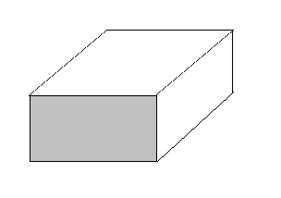  The learners then complete the table below.  edge  face  vertex  Give the class a couple of lessons to complete this task.  Observe and take notes as the learners work together.  Some of the things to look for:  - Are some groups working better than others? Try to explain why you think this is so.  - Are all members of the group participating in the activity?  - Are the learners being encouraged/distracted by the others in the group?  - Are there problem groups? Why are they experiencing problems?  - Did the learners enjoy the activity?  - Do you have any ideas that could be used to promote the ethos of working in groups?  - Design your own activity for your class in which learners will work co-operatively on a topic (idea/concept) relating to one of the assessment standards of your Mathematics Curriculum.  Write down:  - the expected outcomes,  - the apparatus needed,  - explicit instructions for the learners.
  Shape | Name | No. of vertices | No. of edges | No. of faces
  A
  B
  C
  D
  E

Nets for Activity 5 question 2
For all nets: Cut out, fold along all lines and glue tabs.
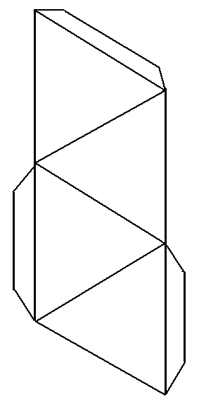
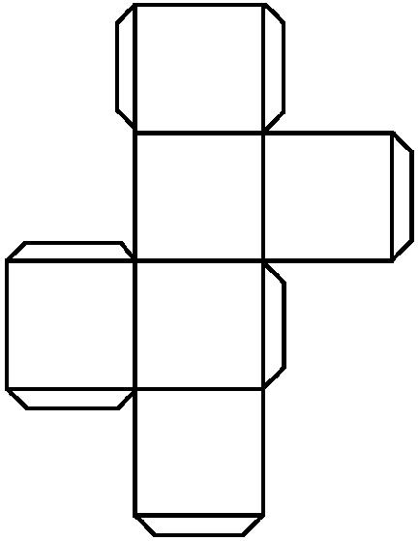
Tetrahedron Net (Triangular pyramid) Cube Net

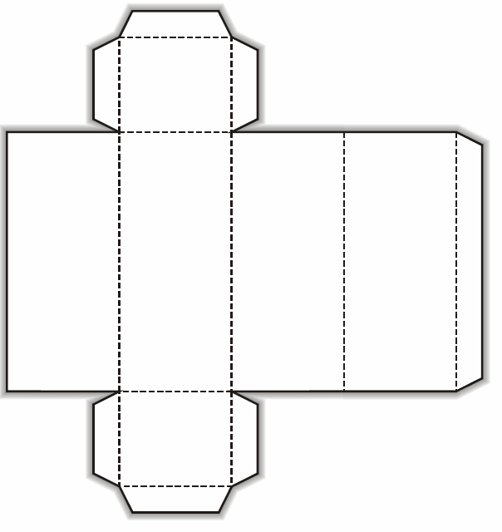
Rectangular prism Net (Cuboid)
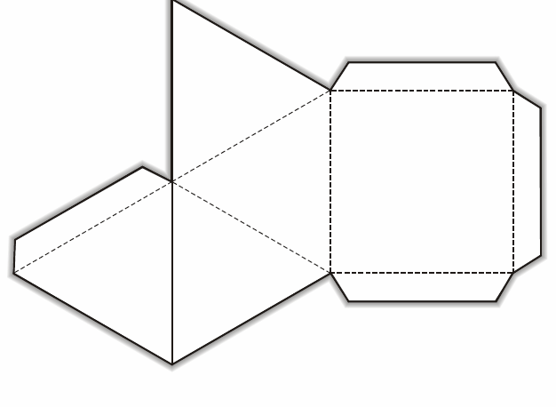
Square pyramid Net

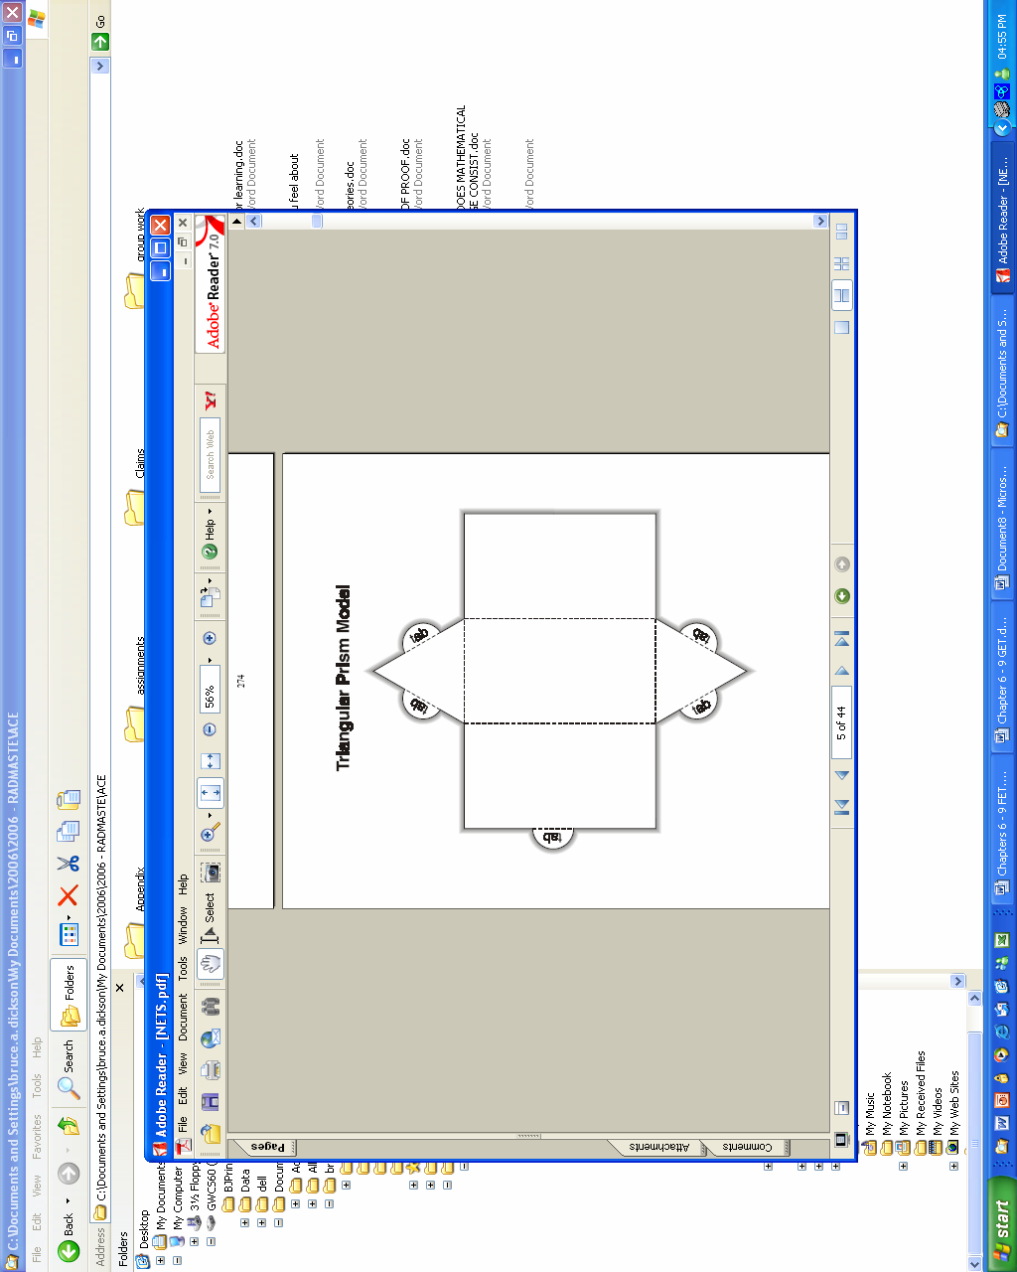
Triangular prism net

Assessing group work
Assessment plays a vital role in the new curriculum and assessment in group work might affect how the learners will interact in the group.
If the teacher believes that co-operative group work promotes individual learning, he/she should design the assessment to facilitate this. Some ways to do this are discussed below.
Group average for each member
Learners work in their pairs or groups and then hand in a group product to be assessed. This group assessment is given to each member of the group. This can be done occasionally to encourage learners to support their partners. Some learners might find this frustrating, particularly if the rest of the group is weak or not interested. This could discourage them from giving their best. Teachers need to be on the lookout for this and guard against it.
Individual mark and group average
Assignments are assessed individually but then count for only a portion of the final mark, say 70%, while the group average makes up the other 30%. This weighting of the marks does not have a great effect on the individual’s mark, but it does provide an incentive to take responsibility for others in the group.
Marks for good co-operative behaviour
Other assessments during the year should also count. Continuous assessment can take place at appropriate times when the teacher is able to walk around and observe, while the groups are busy with work. A simple rating scale of 0, 1 or 2 could be given to the group depending on the involvement of the group members. At the end of the lesson each group should hand in a group effort assessment and marks can be awarded when a serious attempt has been made to reach the goals of an activity.
Below are some examples of assessments that might be used when your class participates in group work. While these assessment sheets or rubrics are specifically designed for group work they can obviously be modified to be used when learners work individually or in pairs.

Self assessment in group participation
It is important that group members learn to assess themselves. They can ask themselves questions such as:
- How did I feel about working in a group?
- Did I contribute to the group?
This rubric that follows can be used for this sort of assessment.

My participation in the group |  | Almost always | Often |  | Sometimes |  | Rarely
I did my fair share of the work
I was considerate to the other members of the group
I gave ideas and suggestions that helped the group
I completed my allocation of work properly and in time.

Peer assessment of group participation
As learners become more familiar with working in groups you can ask them to assess each other, either individually or how they worked as a group.
Fill out the group assessment rubric based on the numbered legend. You are assessing how the members of your group worked together.
4 – excellent; 3 – good; 2 – satisfactory; 1 – inadequate
Group Names | Interaction with members of group | Listened to other members of group | Helped and encouraged other members of the group | Shared the work of the task | Completed assigned work

Teacher assessment of group interaction
Obviously the assessment of learners’ group work by the teacher is an important aspect of learners working together.
 | Excellent | Good | Satisfactory | Inadequate
Group participation | All learners participate enthusiastically | Most of the learners actively participate | At least half the learners contribute ideas | Only one or two learners actively participate
Shared responsibility | Responsibility for task is shared evenly | Responsibility is shared by most group members | Responsibility is shared by less than half the group members | There is reliance on one person in the group
Quality of interaction | Excellent listening skills exhibited; learners’ behaviour reflects awareness of others' views and opinions in their discussions | Learners show some interaction; lively discussion centres on the task | Little ability to interact; some attentive listening; but dominance by one or two group members | Little interaction; very brief conversations; some learners are disinterested or distracted
Roles allocation | Each learner assigned a clearly defined role; group members perform roles effectively | Each learner assigned a role but roles not clearly defined or consistently adhered to | Learners assigned roles but roles were not consistently adhered to | No effort made to assign roles to group members
Co-operative nature of group | All learners take responsibility for their assigned work and ensure that all work by the group is of a very good standard | Learners work on assigned work and most show coopera- tion in completion of task | Learners work on assigned work but less than half are concerned that task is completed | Learners work individually on assigned work and show no co-operation in completion of task
Another way of assessing group work activities is to use a checklist. Checklists consist of statements describing a learner’s expected performance in a particular task. When a particular statement (criterion) on the checklist can be observed as having been satisfied by a learner during the activity, the statement can be ticked off. All the statements that have been ticked off on the list describe the learner’s performance in the group work activity. Checklists are also very useful for peer assessment of activities. The checklist on the next page comes from the LPG for Mathematics in NCS.
Other criteria for assessing group work skills may also be included, as you identify them for the group of learners that you teach.

Criteria | Yes | No
Does the learner perform the designated task in the group?
Does the learner participate fully in group activities?
Does the learner listen to other group members?
Is the learner focused on the group activities?
Does the learner assist other group members when there is a need?

Activity 6 | Read the rubrics given above carefully.  - Evaluate them in terms of your learners and modify them if necessary.  - Use the teacher rubric to assess a group work task/activity in your classroom. Write a short reflection on how you used the rubric.  - Use one of the learner rubrics to assess a different group work task/activity. Write a short reflection on how the learners responded to the rubric.  Note in particular how serious the learners were in assessing themselves and/or each other.  - Design a checklist, similar to the one shown above to assess a mathematics activity for one of your classes. Write a short reflection on how successful the checklist was to assess the performance of the learners.

Dealing with diversity
One of the most difficult challenges facing teachers today is the need to reach all of the learners in an increasingly difficult classroom. Our classrooms all contain a range of learners with different abilities and backgrounds.
In a traditional teacher-directed lesson, it is assumed that all learners will understand and use the same approach and the same ideas - and follow the teacher’s rules or directions in an instrumental manner. This approach does not cater for the range of learner differences in ability. The problem-based approach to teaching is considered to be the best way to teach mathematics and accommodate the range of learner abilities at the same time. In a problem-based classroom, learners make sense of the mathematics in their own way, bringing to the problems only the skill and ideas that they own.
The following list mentions a few specific things that you can do to attend to the diversity of learners in your classroom:
- Be sure that problems have multiple entry points.
- Plan differentiated tasks.
- Use heterogeneous groupings.
- Listen carefully to learners.

Plan for multiple entry points
Many tasks can be solved with a range of methods – especially computational tasks where learner-invested methods are encouraged and valued. This can be achieved by telling the students to use their own ideas to solve a problem. In this way the students will inevitably come up with a number of different ways to complete the task they are given.
Manipulative models can be used effectively to vary the entry points. Learners can also be challenged to devise rules or methods that are less dependent on manipulatives or drawings.

Listen carefully to learners
It is always important to listen to your learners. Try to find out how they are thinking, what ideas they have and how they are approaching problems which are causing difficulty.
Develop an accurate hypothesis as possible about the ideas they have on the current topic.
Every child is capable - by listening carefully you will be in a better position to guide the learners.
The following activity comes from the Malati open source materials, Geometry Module 3 (1999).

Activity 7 | - Discuss how the following activity can be altered and expanded to cater for different learners by giving multiple entry points to the activity. Write out the differentiated activity sheet in full.  More Nets  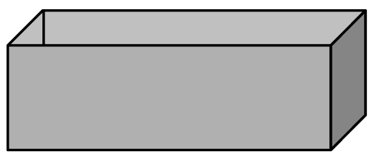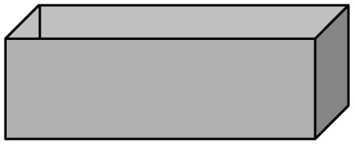  This box without a lid can be unfolded to form a net as shown:  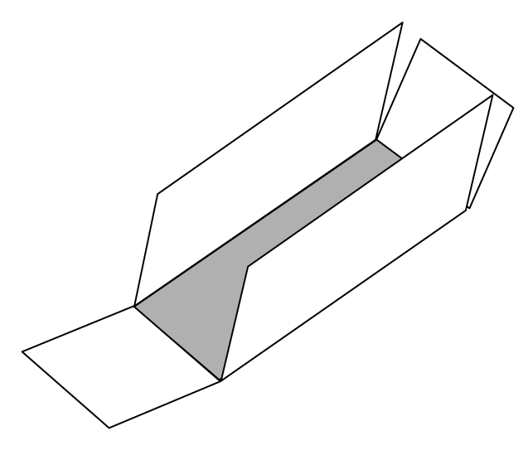  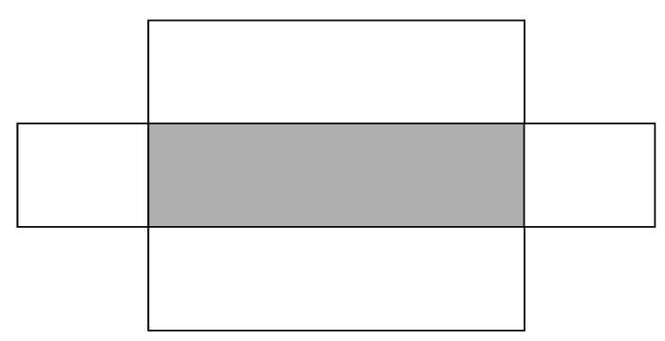  Draw two different nets for the same box.  Draw a net which could be used to make a box with a lid.  How would you change the net to make a cubic box?  - Why is a problem-based approach a good way to reach all learners in a diverse-ability classroom?  - Discuss with your fellow mathematics teachers what is meant by tasks with multiple entry points and differentiated tasks.  - What sort of groupings should be used in a diverse classroom? Why?

Drill and practice
Usually drill and practice refers to the repetitive procedural work that learners are expected to do, in the hope that this will help them learn, or at least, consolidate the new ideas they have been introduced to. However, in the interest of developing a new or different perspective on drill and practice, Van de Walle (2004) offers the following definitions that differentiate between these terms as different types of activities rather than link them together:
- Practice refers to different problem-based tasks or experiences, spread over numerous class periods, each addressing the same basic ideas.
- Drill, on the other hand, refers to repetitive, non problem-based exercises designed to improve skills or procedures already acquired.

What drill provides
Drill can provide learners with the following:
- An increased facility with a strategy that they have already learned.
- A focus on specific methods i.e. no use of flexible alternative methods.
- A false appearance of understanding.
- A rule-oriented view of what mathematics is about.
If you had to convince a traditional teacher why drill alone does not adequately benefit the learner in terms of effective learning, you could motivate your argument using the following points:
- Drill is not a reflective activity
- Drill narrows one’s thinking, rather than promotes flexibility
- There is no indication of conceptual understanding - procedures are easily and quickly forgotten and confused
- There is little joy, interest and enthusiasm
- Drill does not provide any new skills or strategies.
There are some profitable uses of drill:
- An efficiency strategy for the skill to be drilled which is already in place.
- Automaticity, with the skill or strategy, is a desired outcome.
It is possible that the skills that learners need to acquire are weak and unperfected. They then need to be repeated in order to acquire a state of efficiency. However, it is important to note that if the skill is not there to begin with, no amount of drill will create it.
Automaticity means that the skill can be performed quickly and mindlessly - for example, performing long division without thinking about the meaning behind the steps. The mental mathematics of the intermediate phase calls for some drill, to enable learners to work easily with numbers. However, there should always be room for learners to perform their mental mathematics using different strategies that suit them best.
Flexibility is important in computations because the demands of the context suggest different approaches. Even with basic facts, we know that different learners use different strategies. Learners need to learn how to sift through different methods of thinking, which require problem-based tasks and adequate opportunities with varied contexts.

What practice provides
In essence, practice is what your study material is about - providing learners with ample and varied opportunities to reflect on or create new ideas through problem-based tasks.

Activity 8 | Drill and practice  - Analyse these two contrasting terms (drill and practice) as defined above.  - A possible distinction is made between drill and practice. Explain the difference.  - Reflect on your classroom experience and then decide on which activity between drill and practice is more prevalent with the learners.  - Will your observation have any implications on your future classroom practice? Explain your response.  - The drill definition requires that skills are already acquired before they are drilled. What implication will this have for planning problem-based lessons? Explain.

Lesson planning
This unit has given a lot of ideas on planning for and dealing with classrooms with diverse learner groups. To end with, we give you an example of a lesson planning template that you could use (as it is, or adapted to suit your needs) to plan your lessons. Good teaching is based on good planning. There is no substitute for being well prepared for teaching. The annotated lesson plan that follows is presented to give you some indication of the detail to which you should go, in order to ensure that a lesson will go smoothly, and the kinds of learning that you anticipate will actually come to fruition.
The plan refers to the activity sheet below, so you will need to refer this activity as you work through the plan.
Activity 9 | Surface area and volume investigation  Each group of students will get tape, beans, 2 sheets of A4 board and two sheets of A4 paper. Paper plates to catch the beans.  Instructions:  - Take two sheets of A4 cardboard and hold them portrait style.  - Fold one into three equal columns and connect the 297 mm edges with tape.  - Fold the other into four equal columns and connect the 297 mm edges with tape.  - Take two sheets of paper:  - Take the sheet of paper (portrait) style also, and tape the 297 mm edges together. Do not crease this sheet, it should be a cylinder.  - Hold the second sheet of paper landscape style and tape together the 210 mm edges.  Questions to discuss and report back on:  - What is the lateral surface area of the two prisms and the cylinder?  - Fill the triangular prism to the top with beans. Hold the sides rigid - do not let them bow out or they will be cylinders and not prisms. Pour the beans from the triangular prism into the square prism? Does it fill the prism? Mark the height of the beans. Now pour the beans into the cylinder, allow this to bow out (it is supposed to be round). Mark the height of the beans. Does shape affect volume when the surface area is equivalent? Now take the last sheet of paper and pour the Bbeans from the tall cylinder into the shorter one. Mark the height of the beans. What did you observe? What shape do you think will have the smallest surface area for a given volume?

Grade: Example Grade 10
Date: Write the actual date – then consecutive lessons will follow in date order
Learning Outcome(s): Write this in words from the NCS document (Don’t write LO numbers!).
Assessment Standard(s): Write this in words from the NCS document (Don’t write AS numbers!). Write only what is appropriate for THIS lesson ONLY
Lesson outcome(s): Write the outcomes for this lesson ONLY. This must be done in your own words. So for the Surface Area (SA) and volume task (above) you could write: At the end of the lesson the learner should be able to distinguish which prism will have the greatest volume for a fixed surface area.
1.1 |  | Prior knowledge |  | Here you write the knowledge that the learners should already have in order to complete the tasks set in this lesson. Example: learners must be able to name and identify 3D shapes or learners must be able to calculate the volume of a cylinder. | 1.2 Resources | Write down the Physical material needed for this lesson. This includes Printed material like lesson notes and books as well. For example this SA task requires that each group have tape, beans, 2 sheets of A4 board and two sheets of A4 paper
 |  |  |  | What the teacher will do |  | What the learners will do
2.1 |  | Introduction |  | This is the opening part of the lesson. You need to say. What you will do to introduce the lesson.  Example: Ask learners to guess how the volumes of each of the four 3D shapes will compare? Will they be the same? The teacher should not correct them, but allow them to justify their answer without calculation. The expected response is that they will say the volume is all the same since the SA is the same. |  | What will the learners be doing during this introductory part of the lesson?  The learners discuss the questions in groups and justify their hypothesis.
2.2 | Body of the lesson |  | - This is the part of the lesson where the main learning takes place – where new mathematical ideas are investigated / explained etc.  - Remember that you need to consider the different levels of learners’ understanding and cater for them. We want to see that you have included varied types of problems including routine and non-routine types for your learners.  - If it is a teacher explanation lesson:  - Write out in FULL how you will explain the concept. Include leading questions you will ask, and indicate responses you would predict.  - How will you check for understanding of the concepts taught? Don’t just say “I will ask them if they understand.” Explain how you will look for meaningful understanding.  - If you are using a textbook activity, like Classroom Mathematics pg 30 – you MUST attach a copy of the activity.  If it is an investigation activity:  - Explain (as you would to the learners) the task. Break down the instructions etc.  - Attach a copy of the task if necessary.  - Explain how you mediate whilst learners are busy with the task. For example: How do you plan to help learners if they are stuck? |  |  |  | Indicate learner activities during this phase.  How will they be organized in the classroom? Will they be in groups? Pairs? What roles will they have in the groups? How do you expect them to respond? Will they prepare written reports or oral reports? In groups or individually?
2.3 | Conclusion |  | This is where you wrap up the lesson.  How will you:  - Consolidate the learning?  - Check for understanding?  - Look towards the next lesson?  Example: Ask learners to order the prisms and cylinders in order of increasing volume. Perhaps ask them which shape will they use to package peanuts if they wanted it to look like the volume was the most, etc. |  |  |  | What will learners do here? E.g.:  - Summarise their learning  - Report back  - Take down homework  Write out what they need to prepare for next lesson
2.4. |  | Provision for diverse class:  Extension:  Barriers:  Integration: |  | Here you have to write out ways in which you make provisions for your diverse learner group. This may not be required for every lesson, depending on the content. However you should make some provision for each of these categories on the left every week. You need to remember that you should always carefully consider catering for diversity in your classroom.  Extension: This must NOT always be just that you give learners extra work if they are ahead or have completed the task early. Try to provide stimulating and exciting extensions for your learners.  Barriers: Here you can include activities which have been adapted for different learners (You may want to use the Case Study learners as examples of types of learners that you have catered for – Thomas, Libuseng, Joyce, Patience and Joseph – you will get more information about these learners in unit six of this guide.)  Integration: You need to plan for integration. You cannot just write “links to physical science”. You must specify how you will link knowledge gained to these areas.  - For example, you can link the idea of surface area to content in the Science learning area as follows: Surface area is vital in understanding how the skin works. Large surface areas allow for excess moisture to be released quickly. Similarly when deciding how to make your coke colder faster you need to consider surface area and whether smaller cubes or a larger cube with same total volume will be a better option. How about if you wanted to keep it cold for longer, then which one would be a better choice?  - You could also show real world relevance and examples in different contexts.  - Show integration across other maths content – for example, link with other relevant 3D work.
2.5 |  | Homework |  | Specify the homework that needs to be done. It is not necessary to attach textbook activities that are set for homework. You can just include a brief description to clarify the homework task. But for your records you need to write down exactly which activity and which numbers the learners had to do for homework.
2.6 |  | Assessment |  | - This should be an integral part of the lesson – you may have explained the assessment task in the body of the lesson already. You will learn more about assessment in unit five of this guide.  - If you need to explain the assessment strategies here, then you can write it out here.  - You should make sure that you have copies of any tasks, rubrics, peer assessment forms, memos and so on in your file.
3. |  | Reflection: |  | This is a brief reflection:  - Reflections after having taught the lesson (once you have already done this)  - Did it go as planned?  - What changes can you make?  - Write down any comments/ changes/ ideas you have for amending the plan based on your experience of teaching the lesson.
On the next page we provide a blank of the template of the lesson plan, for your use.

Grade:………………………. Date:………………………………..
Learning Outcome(s)
Assessment Standard(s)
Lesson outcome(s):
1.1 Prior Knowledge | 1.2 Resources
 | What the teacher will do | What the learners will do
2.1 Introduction

2.2 Body of the lesson

2.3 Conclusion

2.4. Provision for diverse class:
Extension:
Barriers:
Integration:

2.5 Homework

2.6 Assessment

3. Reflection:

Unit summary

It would be appropriate here to concur with Gagnè & Briggs (1979) who state that the processes involved in an act of learning are, to a large extent, activated internally, however, these processes may be influenced by external events, and this is what makes instruction (or teaching) possible.
Typically then:
Instruction (or teaching) is a set of events external to the learner which is designed to support the internal process of learning (Gagnè & Briggs, 1979).
So you see that the events of planning in the problem-based classroom are designed to make it possible for the learner to proceed from where he or she is, to the achievement of the capability of the mathematics (in the form of ideas, relationships and connections) - these are embedded in the tasks and activities.
The steps given in this unit provide a very practical model for planning in a problem-based classroom. The first four steps are intended to prepare the teacher. This is crucial - decisions made here will define the content, what learners should already know, the prerequisite knowledge and the tasks that your learners will work on. The next four steps are intended to implement the lesson - to make sure that the lesson runs smoothly in the ‘before, during and after’ portions of the lesson.
Finally, you can write a concise lesson plan, knowing that you have thought it out thoroughly.
Planning should reach all the learners in their increasingly diverse classrooms - by using differentiated tasks, allowing for multiple entry points, listening carefully to students and using heterogeneous groupings. Now definitions of drill and practice are used here to further differentiate between the traditional and problem-based approaches.
The lesson structure that you use should promote appropriate reflective thought about the ideas you want learners to develop. Without actively thinking about the important concepts of the lesson, learning will not happen.
How can we make it happen? When planning for a problem-based classroom, take the following suggestions into account:
- Create a mathematical environment.
- Pose worthwhile mathematical tasks.
- Use models and calculators as thinking tools.
- Encourage discourse, discussion and writing.
- Require justification of learner responses.
- Listen actively.

Self assessment
  Assessment | Tick the boxes to assess whether you have achieved the outcomes for this unit. If you cannot tick the boxes, you should go back and work through the relevant part in unit again.  I am able to:
  # | Checklist | ☑
  1 | Describe the step-by-step process of planning for a problem-based lesson. | ❑
  2 | Write out a well thought out and concise lesson plan based on a problem-based strategy. | ❑
  3 | Critically discuss some variations of the three-part lesson. | ❑
  4 | Discuss how workstation activities or games can be profitably and meaningfully used to enhance a problem-based lesson. | ❑
  5 | Discuss the effective use of group work. | ❑
  6 | Explain the differences between competitive learning, individualistic learning and collaborative learning. | ❑
  7 | Discuss the effective use of collaborative/co-operative learning. | ❑
  8 | Plan for reaching all learners through effective problem- solving strategies - to be used in an increasingly diverse classroom. | ❑
  9 | Differentiate between the two terms 'drill' and 'practice' as strategies in the context of problem solving. | ❑
  10 | Analyse the inadequacy of the provision of repetitive 'drill' compared to the varied opportunities provided by practice in the problem-solving situation. | ❑
  11 | Critically reflect on the drill and practice as strategies underlying homework tasks or activities. | ❑

References
 | Bell, FH (1982). Teaching and learning mathematics. WM.C.Brown Publishers: Iowa.  Campbell, PE, & Bamberger, HJ (1990). Implementing Standards. In TE Rowan (Ed), The vision of problem solving in the Standards. Arithmetic Teacher, Vol 37, Number 9, Reston, V.A. NCTM.  Department of Education (2001). Revised national curriculum statement of grades R-9 (schools).  Grange, H. The taming of the tiny shrews. Pretoria News. Friday March 07 2008. P. 11.  Hiebert et al (1997). Making sense: teaching and learning mathematics with understanding. Partmouth, NH: Heinemann.  NCTM (1989). Commission on standards and evaluation for school mathematics. Reston, VA. NCTM.  Malati (1999). Geometry Module 3: Representations (nets, models and cross-sections). Grade 4 to 7 Learner Materials.  Nicholson, MJ (1992). Problem solving. In M Moodley et al, Mathematics education for in-service and pre-service teachers.Shuter & Shooter: Pietermaritzburg.  Polya, G (1980). On solving mathematical problems in high school. IN NCTM, Problem solving in school mathematics 1980 Yearbook. NCTM.  RADMASTE Centre, University of the Witwatersrand (2006). Mathematical Reasoning (EDUC 263). Chapter 6.  Van de Walle, JA (2004). Elementary and middle school mathematics – teaching developmentally. Pearson: New York.

