19

MODULE 4:ICT in Support of Farming

LESSON 4:Seeking and Retrieval of Information

TIME:1 hour 36 minutes

AUTHOR:Walter Wanyama / Dalton Ndirangu





This lesson was made possible with the assistance of the following organisations:

Farmer's Agribusiness Training by United States International University is licensed under a
Creative Commons Attribution 3.0 Unported License.
Based on a work at www.oerafrica.org

4

MODULE 4
ICT in Support of Farming



LESSON

SEEKING AND RETRIEVAL OF INFORMATION

At the end of this module, the participants will be able to:
Understand the technique of searching information using internet and mobile devices.
Appreciate the importance of agribusiness call centres.
Understand important aspects of information seeking behavior.
Understand how people interact with information professionals and information systems when seeking information.

1 hour 36 minutes

TIME:

OUTCOMES:
:

This module is an introduction to the theory and practice of information seeking and retrieval. Emphasis is placed on the roles played by information professionals to assist navigation of the user-system interface, including question negotiation, the formulation of effective search strategies for information retrieval, and the evaluation of information sources and services.

This course supports the four themes: research, reflection, learning, and leading. The ultimate goal is to produce leaders who work together to improve service and learning among diverse populations in farmer organizations.

INTRODUCTION:
:

Walter Wanyama / Dalton Ndirangu

AUTHOR:

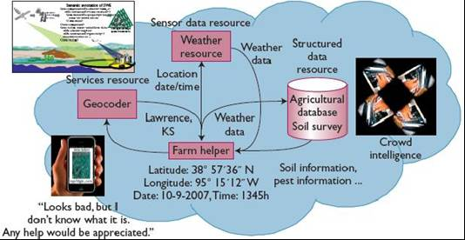

Figure 1: Farmers retrieving information seeking and retrieval on several storage devices.

Figure 1 above illustrates that more and more information is collected from several sources for utilization by the farmers during agricultural activities. Such information could be: to find out about the weather patterns for the next several weeks through the metrological department in Kenya; soil types in a particular location; retrieving pictures of vegetation through the mobile devices, for example, Google maps; pest information and more information from other sources.

Internet Search Techniques

- What is the internet? The Internet is a global system of interconnected computer networks. The Internet includes communication capabilities and many high level applications. For example, the Internet includes the World Wide Web, your e-mail clients, list servers, and many other services. The existing connectivity of the Internet makes it possible for users and servers all over the world to participate in various activities. Below is an example of a typical World Wide Web address or Universal Resource Locator, URL:-
.

Reading a URL Address

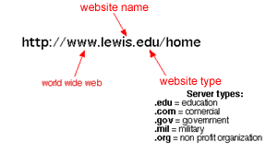

Googlewww.google.com Currently the most well-known search engine. It has risen to prominence because it ranks sites according to popularity. It uses the number of links to a site to determine how important the site is relative to others and places these linked to sites high up in the returned search results. Google also has specialised searches for blogs, images, news, scholarly journals, patents and books. Its interface is also extremely simple and easy to use.
2. Internet search tools and techniques
Search Tools
What is a search engine: A web search engine is designed to search for information on the World Wide Web; below are examples of six different search engines each with different search strategies and services.

Yahoowww.google.com This is the ‘grandpa’ of search engines and has over the years built up a loyal community around it. The search facility appears at the top of the page and a portal filled with numerous services and content appears on the same page. Noteworthy features include shortcuts to dictionary, synonyms, patents, traffic, stocks, and an encyclopaedia.
Askwww.yahoo.com Ask uses a system called Subject-Specific Popularity™ ranking that allows you to suggest a broader or narrower search thereby filtering your search results. It too has an encyclopaedia that is very useful.
MSN Searchwww.ask.comThis is a popular search facility for those people who use the Microsoft Network portal, MSN. In the USA, MSN search accounts for about 10% of all Internet searches.
Monster Crawlerhttp://www.msn.com/ Monster Crawler is an example of a meta-search engine that coordinates searches using all of the top 5 US search engines: Google, Yahoo, MSN, Ask and AOL. While it might make sense that more heads are better than one there are some academics that believe that the results returned by meta-search engines are no better than those sites using one system. Try it out and see for yourself.
Note: For more example visit the following URL Link http://www.internettutorials.net/engines.asp

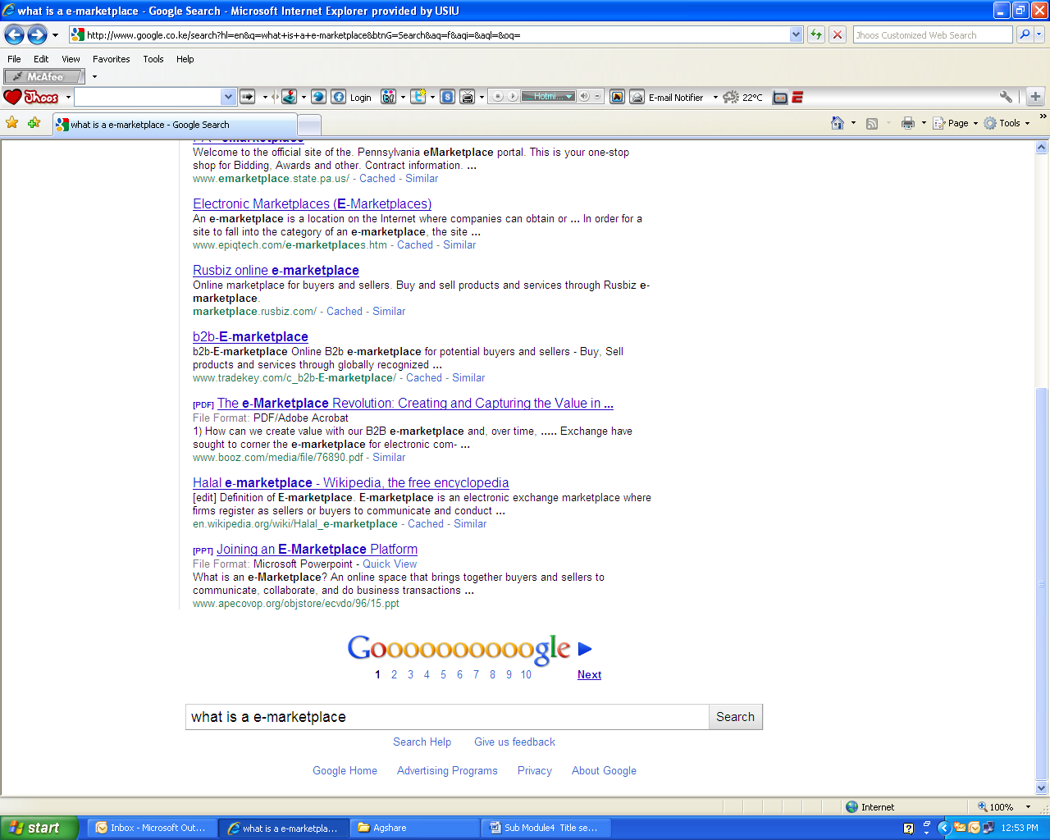
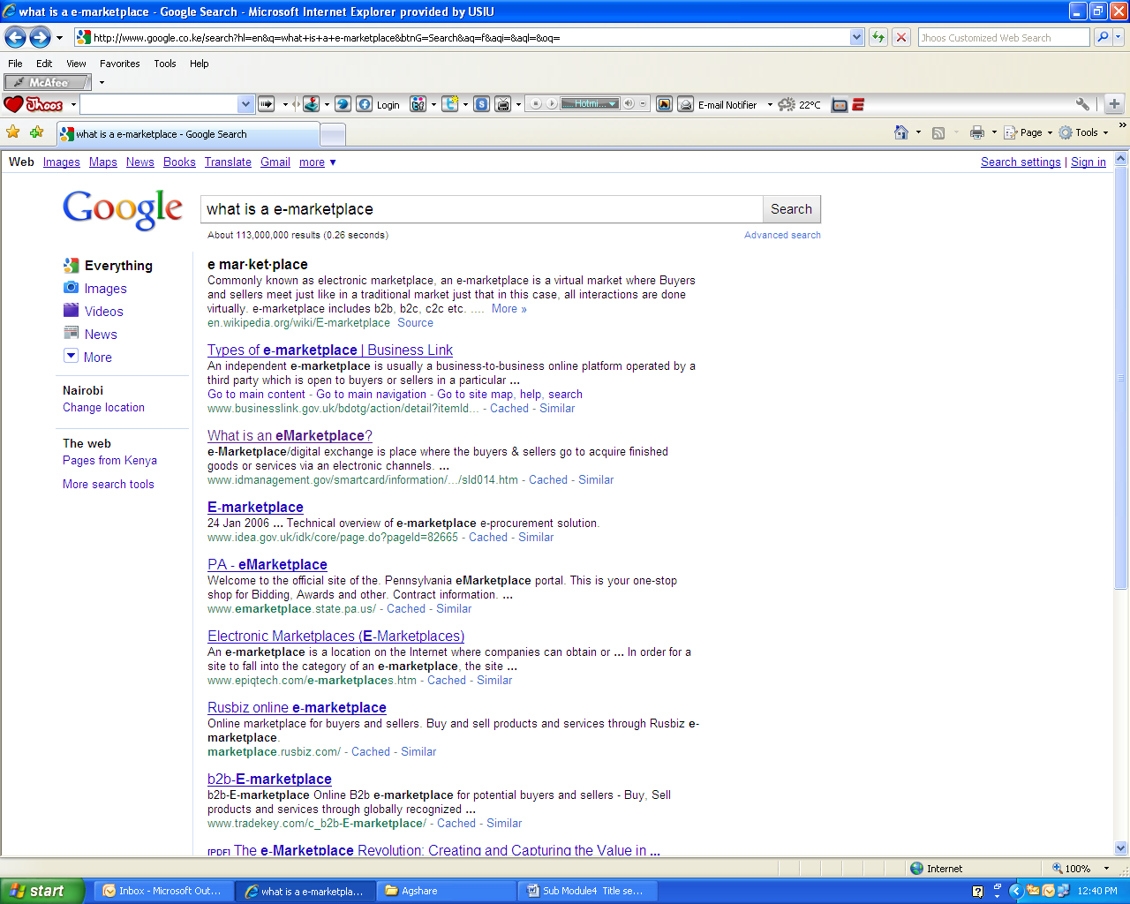
Figure 3: Search Field in Google

Figure 4: Google Search Results

Search Techniques
Whenever you receive important information about which you are uncertain, there are several ways you can try to verify what you've received. Here are a few key techniques you can use to verify information and find the best sources:

- Pick out key words that identify the topic you are searching for. For example in figure 3 below the keywords are “What is a e-marketplace”.
- Type them into the search field within a search engine. Below in figure 3 this has been done in Google.

On the results list, scan the URLs written in green at the bottom of each search result entry:
- Look for the most reliable source listed.
- Use different search engines such as Google and Yahoo, or any other, as results often differ.

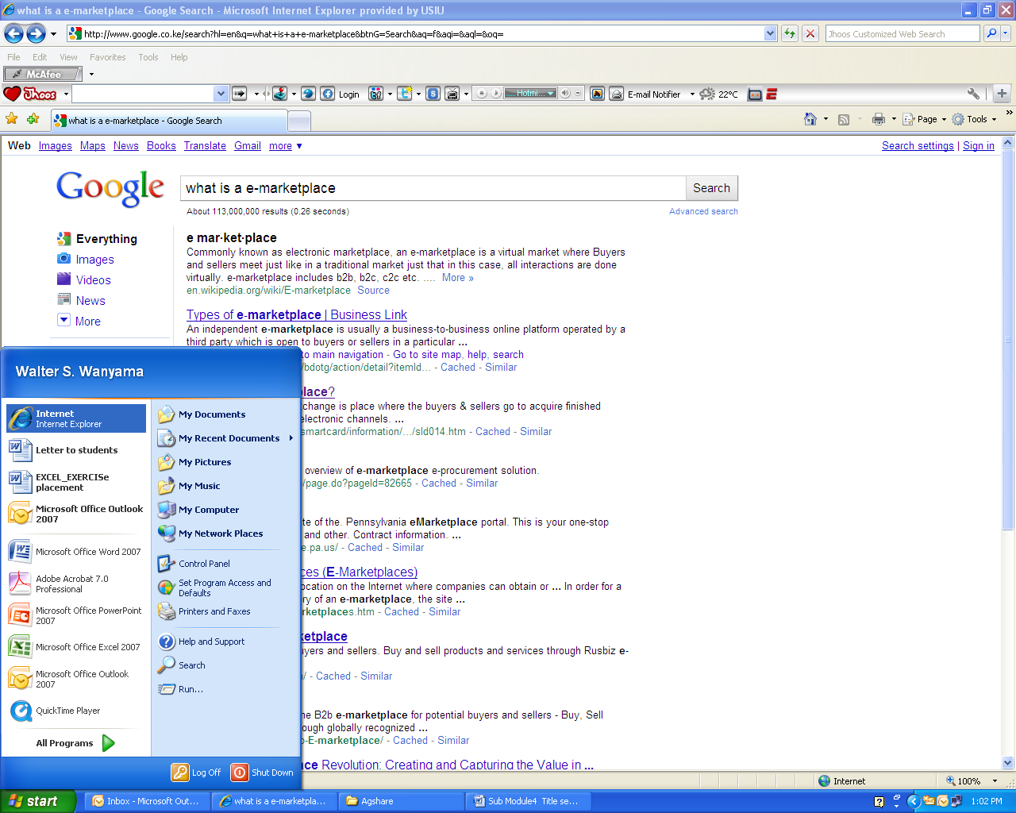

Internet Search Exercise
Open the computer’s Internet browser program.
In figure 5, below, the user has opened the program, Internet Explorer.

Activity 1

Figure 5: Windows menu used to access an internet browser
to launch the internet Results

If you find the message ‘repeat the search with the omitted results included’ it may be worthwhile to click it to find more results.
If you don't immediately find a good source, search both on the search engine's regular search page and its news search page. The news search can be found in the string of links at the very top left of the page on Google or in the dropdown ‘more’ menu on Yahoo. The regular search is more complete, but often has many entries from non-reliable sources.


Figure 6: Yahoo!

In the Search Engine’s search field, type in your key words e.g. ‘Kenya Meteorological Department website’
From the results displayed, open the Kenya Meteorological Department website. Write on a piece of paper the features that are included in this website. Identify and list other links to this website.

In the browser, navigate to your preferred search engine. To do this type the URL in the browser’s address bar. Open any search engine and perform the following exercise. In the example in figure 6 the user has typed in the URL www.yahoo.com

Mobile Information Search Techniques

Mobile devices can also be used to access information. In recent times this technology has become effective in supporting access to real time information. Farmers should know how to retrieve information using mobile devices and how to exchanges information with other farmers or potential buyers.



Figure 7: Display of information search using mobile device
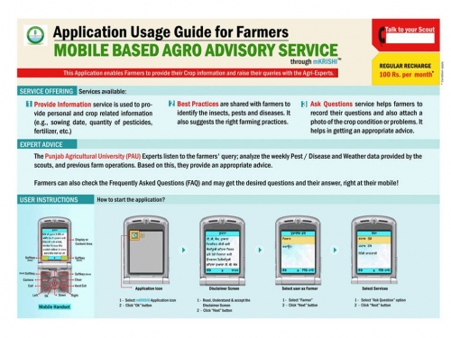

Figure 8: Mobile based agro advisory services; depicting how mobile phone can be used access information from agro based information to guide farmers on farm activities. The example shown here can be accessed at http://www.kissankerala.net/mobile/index.jsp

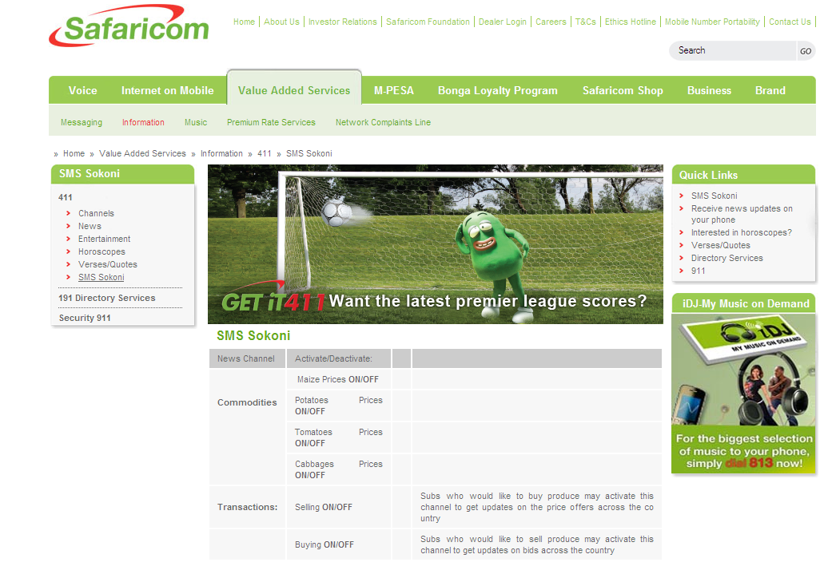
Individual work
If your mobile phone has a Safaricom (Kenya) SIM card, locate the Get-it 411 service using the SIM tool kit and access Agricultural related information. The following services are available.
Latest commodity prices
Latest and updated news
Latest stock prices
Sports scores
Get-it 411 is an innovative information service that allows you to request information by sending an SMS message. The information that you request is instantly sent back to you by return SMS. All Safaricom subscribers have access to this service.

Activity 2

Figure 9: Safaricom (Kenya) website showing SMS Sokoni where farmers have access to market commodities prices.

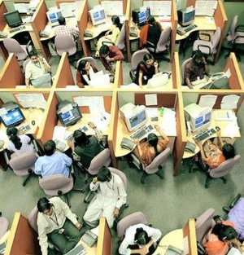
Agribusiness Call Centres
A call center is an office where a company's inbound calls are received or outbound calls are made. Call centers are increasingly popular in today's society, where many companies have centralized customer service and support functions. Call centers employ many staff in customer service, sales, and support functions.
Call centers are often large offices staffed with representatives who either make or receive phone calls. Depending on the size of the call center, a single office could have anywhere from a few dozen to hundreds of telephone staff. Depending on the needs of the company, call centers can make either incoming or outgoing calls.
Benefits of Call Centre
Farmers can speak to a person directly.
Many Call Center representatives are multilingual.
Calls to these centers are often free or subsidized.
Call Center services can free up your time allowing you to focus on the work and provide more time for marketing and advertising and less time solving issues.
Call center representatives answer calls professionally and answer queries with intelligence and detailed product knowledge.

Figure 10: People working at an agricultural call centre


The graphic below identifies a number of important web sites that have important information on various issues that impact on agriculture. Three of the services identified below have additional ways for farmers to access the information.

Information Retrieval from Agricultural Based Organisations and Government Agencies

Web / Individual Activity
Open KARI Website, http://www.kari.org, and investigate. Then visit links of other organizations with which KARI has linkages.
Open ILRI Website, http://www.ilri.org. Investigate the ILRI website, open information concerning People, Livestock and the Environment, copy the information to Microsoft Word, and save on the computer’s desktop.

Activity 3


Conclusion
Summary
In this lesson you have been introduced to the importance of information seeking and retrieval in the agricultural setup through modern technologies. More and more data is collected from several sources and stored in a database to be accessed by farmers for their agricultural activities. Such information includes weather information, agricultural commodities prices, fertiliser, soil types and many other types of information. If the farmers are equipped with this knowledge, there is a greater possibility of success in agricultural activities.

The main points of this lesson are:
For successful farming activities to be carried out, farmers should know how to access crucial information. There is much agricultural information online stored and distributed through several agricultural organizations
The lesson provides insights on how online (both internet and mobile devices) have revolutionized information seeking and retrieval. For example, Get-It 411, where farmers are able to access commodity exchange prices on agricultural products.

Enrichment Resources
Read more on search engines http://www.internettutorials.net/engines.asp
Watch video on using search engines: http://www.youtube.com/watch?v=5h9E6B9Emgk and
http://www.youtube.com/watch?v=iRU9iNlqV0E
Agricultural production video: http://www.youtube.com/watch?v=55CVAtK6v7s
ICT and Agriculture video: http://www.youtube.com/watch?v=BS01QnQ57KI
Agriculture, Technology & the Developing World: http://www.youtube.com/watch?v=GKfWT_O9DKs
Use of ICT by smallholder farmers in Kabale, Uganda: http://www.youtube.com/watch?v=824KA38hvDI
The World Bank - Towards 2020: ICT in Action in Rwanda: http://www.youtube.com/watch?v=8UYBw0nSr1o

