3: How to use the Library

Introduction
Bunda College Library is the heart of teaching, learning, research and consultancy activities of the College. As part of your studies you are required to supplement whatever you learn in class, field, laboratories, etc with information available in the Library. Users, especially students, need to know how best to use the Library.

Outcomes
At the end of the chapter it is expected that you will be able to:
  - identify the various sections of the Library and their contents
  - describe the University of Malawi regulations
  - identify the various information sources
  - describe the information searching process
  - describe information searching tools

Library Staff and Sections
The Library comprises a College Librarian, Assistant Librarians, a Secretary, Library Assistants, Library Guards and Messengers/Cleaners. The College Librarian is the overall in charge of the Library. Library staff assists users in:
- Searching and retrieving information
- Issuing out and receiving Library materials
- Provision of special services such as printing, scanning, lamination, photocopying, ID production and Internet/email access.
- Allocating Library equipment, such as computers; audio-visual materials and study carrels.
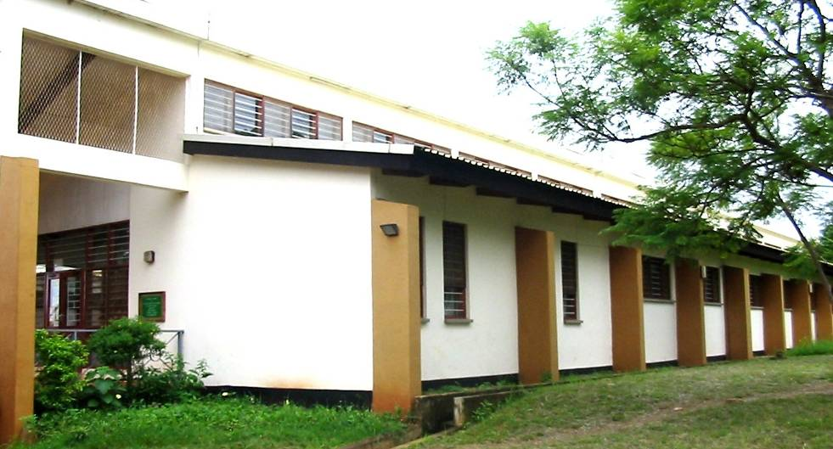
Part of Bunda College Library Building
The Library is composed of the following sections/areas:
  - Entrance foyer
  - Guard’s desk
  - Offices
  - Information desk
  - Long term/short loans desk
  - Malawiana collection
  - Audio-visual
  - Food and Agricultural Organization (FAO) collection
  - General books collection
  - Bound periodicals section
  - New periodicals display rack
  - References
  - Computer room
  - Maps and atlases section
  - Study carrels
  - Open study/reading areas
  - Newspaper reading area

Library users are free to visit or take an available seat or reading desk in any of the Library sections/areas.

All registered Library users are issued with pockets to be used for borrowing Library materials. The number of pockets and the period a user can borrow items before returning, depends on the category of the user as stipulated in the University of Malawi Libraries’ regulations.

 Self Study Activity: Library Sections

Pay a visit to the Library and familiarize yourself with each section and area as outlined above. Take note of their contents and/or activities.

- Describe what you do if you want to take a book out the Library.
- What are the two major differences between Malawiana and general books collections?
- From which section(s) are you allowed to take out Library materials?

Library Regulations
Bunda College of Agriculture Library is part of the University of Malawi (UNIMA) Libraries. University of Malawi has a library in each of the five constituent colleges. As such all UNIMA libraries follow the same regulations. All Library users must know these regulations and follow them; otherwise there are stipulated penalties for not doing so. The following are some of the regulations:

- No eating or drinking in the Library
- Library materials must be handled with care; no scribbling, soiling or tearing or turning down pages
- Noise must be minimized to maintain a good study environment.
- Cell phone use in the Library is not permitted.
- Games or offensive materials on Library computers are prohibited
- Leave hats, bags, umbrellas at the Guard’s desk
- Some Library collections which are appropriately marked ‘Not To Be Taken Away’ or ‘Malawiana’ or ‘Thesis’ shall not be removed from the Library, except under very special circumstances and at the discretion of the College Librarian.
- The Librarian reserves the right to withdraw or refuse Library facilities to anyone who contravenes the Library Regulations.

In summary, treat the Library and its contents with care and respect and it will serve you and future students well!

Self Study Activity: Regulations

Go through University of Malawi Libraries Regulations posted on the Library Guard’s Desk.

- How long are you allowed to borrow a Library material from the Reference section for?
- What are penalties for users who lose books or delay in returning a book?

Types of Information Sources

  - Printed materials
    - Books
    - Periodicals
    - Unpublished materials

  - Electronic Resources
    - Electronic journals
    - Online databases
    - Computer/local databases
    - CD-ROM
    - Electronic books

Self Study Task: Book & Periodical Details

- Get any book from the shelves and write down the author(s)/ editor(s) (if any), title, publisher, date of publication, index pages (if any) and glossary (if any).
- What is the difference between a book and a periodical?

Information Searching Process
Searching information in the Library involves having an idea of what one is looking for. A Library user has to plan before doing the searching. The plan should include knowledge of the information source, tool(s) to use, section(s) of the Library holding the information source and what steps to take if you don’t find the information you are looking for.

Tools for Information Searching

Library catalogues
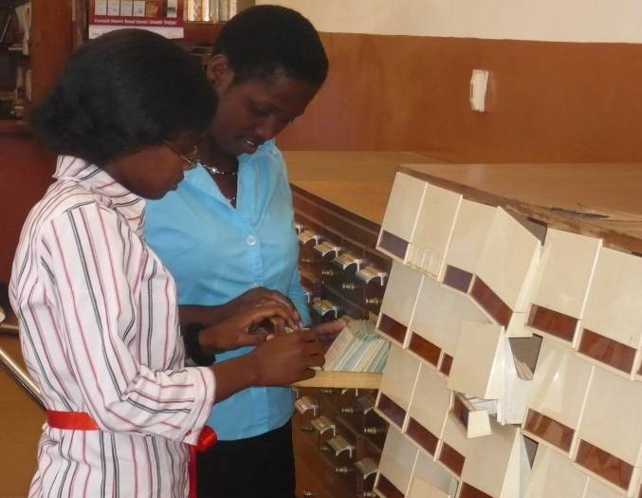
Library catalogues are a listing of all what is contained in the Library in a certain order. Bunda College of Agriculture Library uses classified and alphabetical order. The Library has two types of catalogues namely card catalogues and online public access catalogues (OPACs) that uses computers. Card catalogues situated near the main entrance, contain records for books acquired from Bunda College of Agriculture inception to 1990 when computers were first used. The card catalogue is in two parts: Author/Title and Subject catalogues. The cards contain bibliographical details of an item such as author(s)/editor(s), publisher, place of publication, date, imprint, physical description, class mark and subject(s) the item covers. Class mark is the location of an item in the Library. Cards in the catalogue are filed in alphabetical order.

From 1990 to 2001 the Library created online databases for its books and pamphlets using a database management system called CDS/ISIS. The databases contain bibliographical details of an item.

Students Searching for Library materials using a Card Catalogue
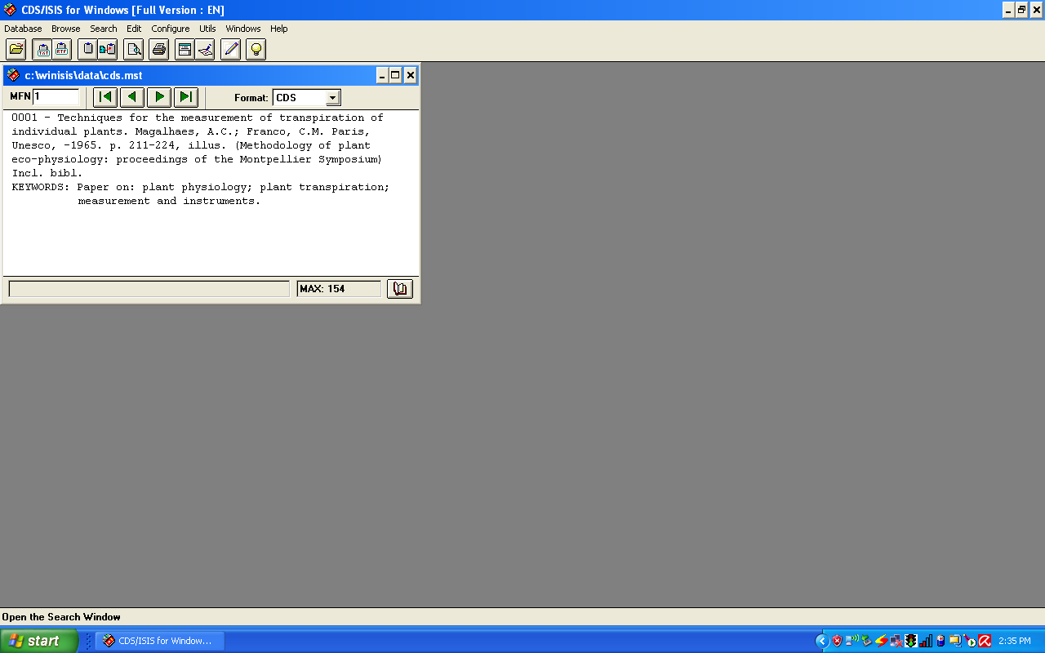
Online Database

Then, using integrated Library software, Library.Solution, the Library created an online public catalogue (OPAC).

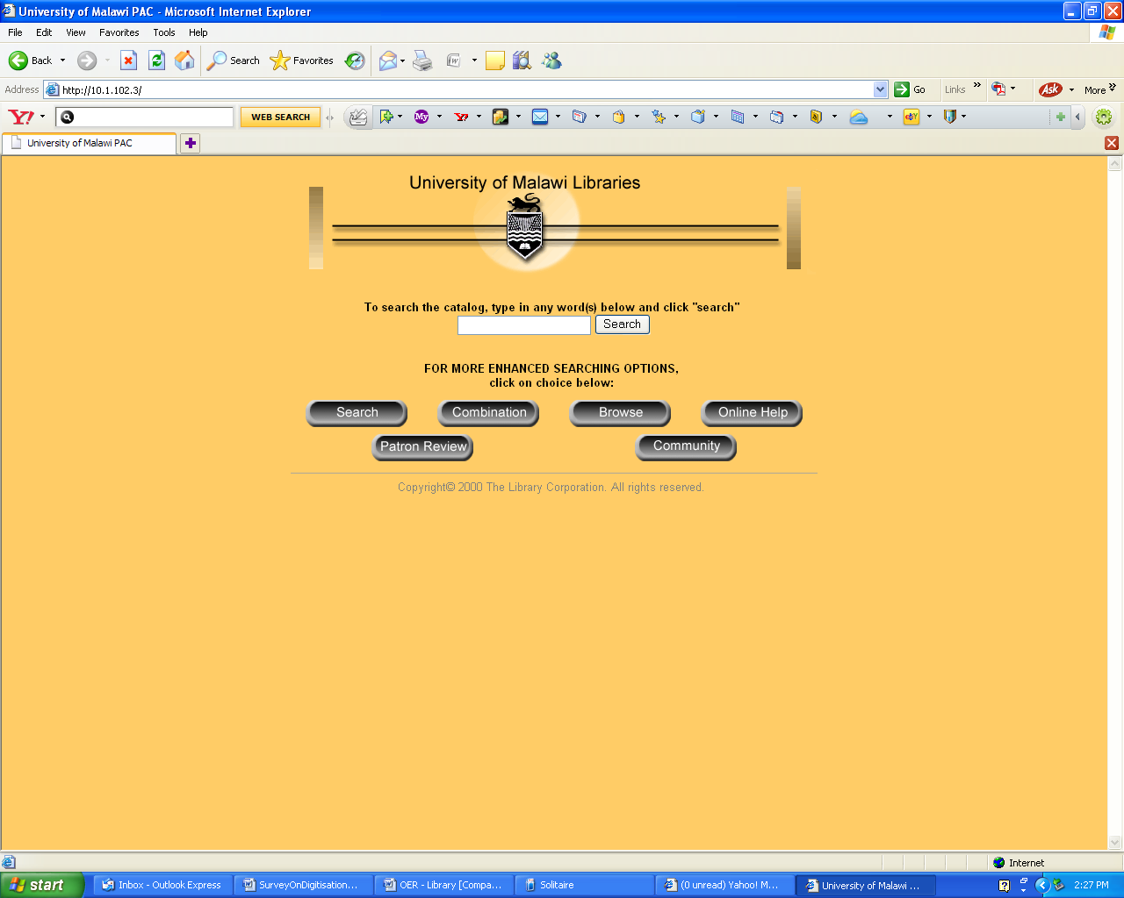
Bunda College Library Online Public Access Catalogue (OPAC)
In using a Library catalogue, a user takes note of the class mark before s/he retrieves an item. If a record for an item is not available in the catalogues ask Library staff. Likewise if an item is not available on its location in the Library, seek Library staff’s assistance.

Books in the Library are classified using a Library of Congress Classification Scheme. Library of Congress Classification Scheme divides knowledge/subjects under the universe into letters from A–Z.

Online Information Resources
The Library has access to various electronic information resources. Some of the resources are for free whilst others the Library subscribes to. The Library has produced a list of all the electronic resources available to Bunda College of Agriculture Library users. The list provides the name of the resource, a brief description of the resource and universal resource locator (URL), and where necessary username and password. Almost all the resources are IP (Internet Protocol) authenticated as such users do not require inserting a username or password. Most of these resources are supposed to be used within Bunda College of Agriculture campus. A list of the electronic resources available to Bunda College of Agriculture Library is available on the Library’s Information Desk.

Seminar Activity: Search Tactics

With the assistance of a Library staff, search the following book: Fundamental of Organic Chemistry by T.W. Grahams Solomons in the card cataloguing. Using OPAC, search for the same book.

With the assistance of a Library staff search in at least two electronic resources the term: pasture management.

Chapter Assessment Task

- Using any of the Library catalogues give class marks of books by:

  - Roling, Niels G. titled ‘Extension Science Information: Systems in Agricultural Development’.
  - Bennion, Marion titled ‘Introductory Foods’.

- Mention three things you need to know before you start searching for information / a book in the Library.

- Using any of the Library catalogues give the title of a book by:

  - Palalia, Diane E. A
  - Edited by Owen, J.B. and Oxford, R.E.E.
  - Ngalande Banda, Ellias E.

- In which collection do you find books with a class mark that is preceded by?:
  - REF
  - MAL

- Give author(s) and title of the books whose class marks are:

  - QP 31.2 SCH 1990
  - REF SB613 .S6 BRO 2006

 Additional Enrichment Resources
The following web resources are highly recommended and will offer enrichment:

Name | Web Address
How-To-Study.com,  Using Reference Sources | http://www.how-to-study.com/study-skills/en/studying/41/using-reference-sources/
About.com,  Using a Library | http://homeworktips.about.com/od/libraryresearch/a/using.htm
Wikipedia,  Dewey Decimal Classification | http://en.wikipedia.org/wiki/Dewey_Decimal_Classification
VUMA! Portal,  Research | http://www.vuma.ac.za/drupal/?q=content/research-0

